Oracle WebLogic Server on Docker Containers

Oracle White Paper |July 2016

Table of Contents

Oracle WebLogic Server on Docker 2

Oracle WebLogic Server Docker Images 4

Custom Built Oracle WebLogic Server Images 4

Dockerfiles and Scripts on GitHub 5

Dockerfile 5

Scripts 6

Clustering Oracle WebLogic Server on Docker Containers 6

How to Build and Run 9

Dockerfiles 9

Scripts 10

Building a Oracle WebLogic Server Image 10

Samples for Oracle WebLogic Server Domain Creation 11

Sample Domain for Oracle WebLogic Server 12c 11

Write your own Oracle WebLogic Server domain with WLST 11

Building a sample Docker Image of Oracle WebLogic Server Domain 11

Running Oracle WebLogic Server Admin Server Container 12

Running Oracle WebLogic Server Managed Server Container 12

Oracle WebLogic Server Docker Container Communicating With Servers on a Remote Host 15

Additional Considerations Running Oracle WebLogic Server with Docker 16

Conclusion 18

Oracle WebLogic Server on Docker

We are announcing that Oracle WebLogic Server (WLS) is now certified to run on Docker containers. As part of this certification, we are releasing Dockerfiles and supporting scripts on GitHub to build images of the Oracle WebLogic Server. These images are built as an extension of existing Oracle Linux images. You can use these Oracle WebLogic Server Docker images or create your own.
Docker is a platform that enables users to build, package, ship and run distributed applications. Docker users package up their applications, and any dependent libraries or files, into a Docker image. Docker images are portable artifacts that can be distributed across Linux environments. Images that have been distributed can be used to instantiate containers where applications can run in isolation from other applications running in other containers on the different host operating systems or VMs.
The table below describes the certification provided for various Oracle WebLogic Server versions. You can use these combinations of Oracle WebLogic Server, JDK, Linux and Docker versions when building your Docker images.

WLS Version | JDK Version | Host OS | Kernel
12.2.1 | 8 | Oracle Linux 6 | UEK4
12.2.1 | 8 | Oracle Linux 7 | UEK4
12.2.1 | 8 | Oracle Linux 6 | UEK4
12.2.1 | 8 | Oracle Linux 7 | UEK4
12.2.1 | 8 | Red Hat Enterprise Linux 7 | UEK4
12.1.3 | 7/8 | Oracle Linux 6 Update 5 | UEK 3 (3.8.13)
12.1.3 | 7/8 | Oracle Linux 7 | UEK 3 (3.8.13)
12.1.3 | 7/8 | Red Hat Enterprise Linux 7 | UEK 3 (3.8.13)

For additional details on the most current Oracle WebLogic Server supported configurations and support statement please refer to Oracle Fusion Middleware Certification Pages.
These Dockerfiles and scripts we have provided enable users to create clustered and non-clustered Oracle WebLogic Server domain configurations, including both development and production running on multiple host host operating systems or VMs. Each server running in the resulting domain configurations runs in its Docker container, and is capable of communicating as required with other servers. Other configurations and approaches are possible; this paper will guide you to create these configurations.

Oracle WebLogic Server Docker Images
We are releasing Dockerfiles and supporting scripts to build Oracle WebLogic Server Docker images on GitHub. These images are built as an extension of existing Oracle Linux image 7.0, with JDK 7 or 8, and the Oracle WebLogic Server 12c (12.2.1 and 12.1.3) installations.
Two type of images can be created,
- An Oracle WebLogic Server image created with the Generic installer.
- An Oracle WebLogic Server image created with the Developer installer.

Base Image
Oracle Linux
Oracle JDK
WebLogic Server Installation
JDK image
WebLogic Server Install Image


Fig 1. Oracle WebLogic Server Docker Image

Custom Built Oracle WebLogic Server Images
You can create your own Oracle WebLogic Server Docker images. To help you with this, we have posted Dockerfiles and scripts on GitHub Oracle WebLogic Server Docker files as examples for you to get started.
What are the prerequisites to build the custom WLS images?
- Oracle Linux base image.
- Dockerfiles and scripts from GitHub.
- Oracle WebLogic Server Generic installer or Developer installer.
- Corresponding JDK.

Dockerfiles and Scripts on GitHub

Dockerfile
The Dockerfile to create an Oracle WebLogic Server install image performs the following functions:
- Extend the Oracle JDK image
- Installs WLS using the (WLS generic/Developer installers) in silent mode
After creating your Oracle WebLogic Server install images, you can extend them to have a base Oracle WebLogic Server domain configured.
The Dockerfile to create an Oracle WebLogic Server domain image performs the following functions:
- Extend the Oracle WebLogic Server install image.
- Configure a WLS domain by calling Oracle WebLogic Server Scripting Tool (WLST) scripts. The domain has one Admin server, JMS server, Data Source, enables JAX-RS 2.0.
There are additional Dockerfiles to create an Application image, the Dockerfile performs the following functions:
- Extend the domain image.
- Deploy an Application to an Oracle WebLogic Server domain.
Application Image
Application

WebLogic Server Domain
Domain Image
WebLogic Install Image
WebLogic Server Instllation
JDK Image
Oracle JDK

Oracle Linux
Base Image

Fig 2. Oracle WebLogic Server Domain and Application Image

Using the Oracle WebLogic Server domain image you can create two types of containers:
- Admin Server container with a single Oracle WebLogic Server Admin Server.
- Managed Server container with a Node Manager, which adds itself as a machine to the Admin Server and a Managed Server.

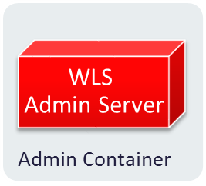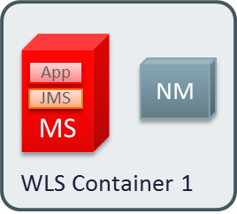

Fig 3. Types of Oracle WebLogic Server Containers

Scripts
There are WLST and shell scripts, these scripts aid in the creation of the Oracle WebLogic Server domain image and serve as examples to extend the Oracle WebLogic Server domain image to create more sophisticated configurations.

Clustering Oracle WebLogic Server on Docker Containers
Oracle WebLogic Server has a Machine concept, which is an operational system with an agent, the Node Manager. This resource allows Oracle WebLogic Admin Server to create and assign Managed Servers of an underlying domain in order to expand an environment of servers for different applications and resources, and also to define a Cluster. By using Machines from containers, you can easily create a Dynamic Cluster by simply firing new Managed Server containers. With WLST, your cluster can scale in and out.
These Docker containers enable users to create clustered and non-clustered Oracle WebLogic Server domain configurations. Each server running in the domain runs in its own Docker container and is capable of communicating as required with other servers.

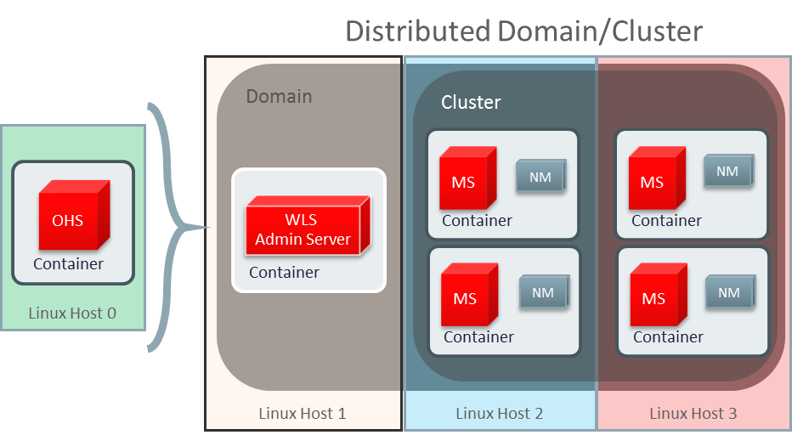
Fig 4. Clustering Oracle WebLogic Server on Docker Containers
The advantages of this topology
- Good for traditional-like deployments.
- Easy to deploy containers from Oracle WebLogic Server domain images.
- Easy to scale up and down the cluster.
- Great for developers looking for lightweight, repeatable, and shareable WebLogic environment
- Continuous Deployments
- No need to install or configure anything on host except for Docker binaries.
A topology which is in line with the “Docker-way” for containerized applications and services consists of a container designed to run only an administration server containing all resources, shared libraries and deployments. The Docker image includes all domain resources pre-defined, applications and shared libraries deployed upfront, and no Managed servers or clusters configured.

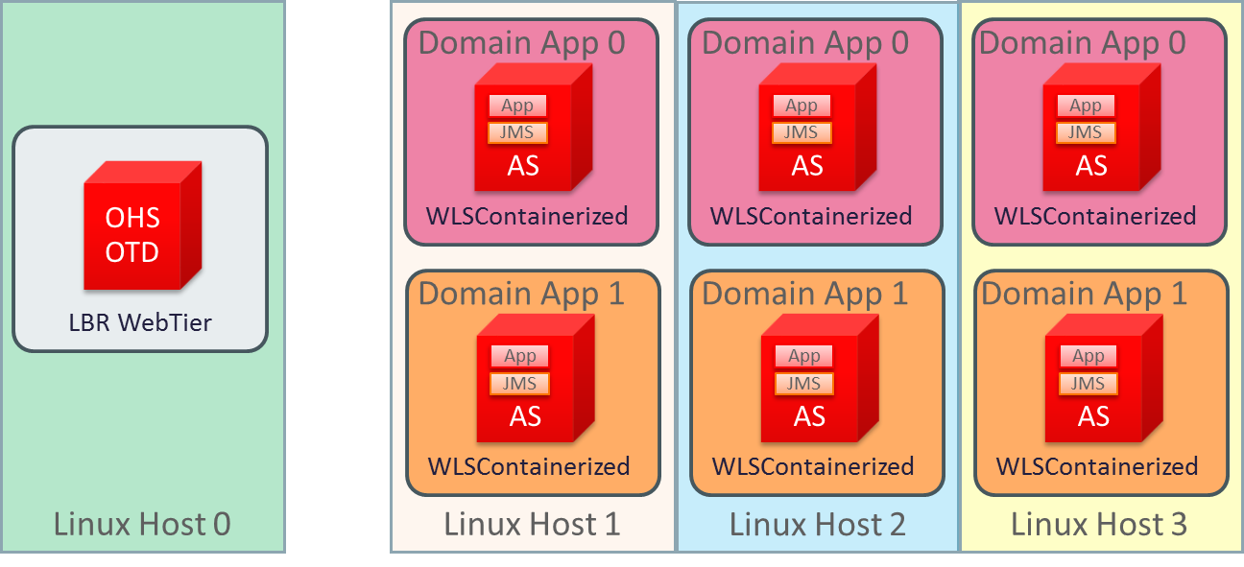
Fig 5. Containerized Oracle WebLogic Server Applications

The advantages of this topology
- The “Docker-way” for containerized applications and services.
- Containers are easily repeatable
- Each container is an instance of the same Oracle WebLogic Server domain.

How to Build and Run
On GitHub you will find Dockerfiles and supporting scripts needed to build an Oracle WebLogic Server install image and to extend this image to create an Oracle WebLogic Server domain image. Download the entire directory structure to build your Oracle WebLogic Server images and start your containers.

Dockerfiles
Two Dockerfiles for each Oracle WebLogic Server 12c (12.1.3 and 12.21) under the ~/OracleWebLogic/dockerfiles/12.x subdirectories, one Dockerfile to build an Oracle WebLogic Server 'developer' install image and a second Dockerfile to build an Oracle WebLogic Server 'generic' install image.
Dockerfile.developer
Dockerfile.generic

Scripts
Under the ~/OracleWebLogic/samples, ~/OracleWebLogic/samples/12xx-domain/container-scripts you will find supporting scripts. These scripts, build an Oracle WebLogic Server domain image..
createMachine.sh – starts a Node Manager in the container and calls addMachine.sh to start Node Manager and add the Node Manager machine.
createServer.sh – starts a Node Manager in the container and calls add-server.py to configure a Managed Server in the machine create by add-machine.py.
create-wls-domain.py – WLST script configures a base domain with one Admin server, JMS server, JSP, Data Source.
add-machine.py – WLST scripts to create a machine using the Managed Server container name.
add-server.py – WLST scripts to create a Managed Server.
commonfunc.py – Common WLST calls
rm_containers.sh – removes all running containers
clean-up-docker.sh - removes all ghost containers and all ghost images

Building a Oracle WebLogic Server Image
To build the Oracle WebLogic install image you must first have the Oracle Linux and Oracle JDK images already running. Pull the Oracle Linux 6 or 7 image from Docker Hub and to create your Oracle JDK image. To create the Oracle JDK image download the Dockerfile from GitHub/Oracle JDK, this Docker file extends the Oracle Linux image and installs the JDK, download the JDK into the ~/OracleJDK/java-x directory.
$ sudo docker build –t oracle/jdk:8 .
Now build the Oracle WebLogic install image, first decide which installation type you want to use either Generic or Developer installer, download the required Oracle WebLogic Server installer in the dockerfiles/12.x folder. For Oracle WebLogic Server 12.1.3 use either the Generic or ZIP installer, for Oracle WebLogic Server 12.2.1 use either the Generic or Quick installer. Go into the OracleWebLogic/dockerfiles folder and run the buildDockerImage.sh script as root. In the instructions bellow replace 12.x.x for the right version either 12.1.3 or 12.2.1.
$ sudo sh buildDockerImage.sh -h
Usage: buildDockerImage.sh [-d|-g] [-v] 12.x.x
Parameters:
-d: creates image based on 'developer' distribution
-g: creates image based on 'generic' distribution
-v: WebLogic Server version
Note: the resulting image will NOT have a domain pre-configured. We provide a separate Dockerfile and supporting scripts to extend the Oracle WebLogic Server install image and create an Oracle WebLogic Server domain image.

Samples for Oracle WebLogic Server Domain Creation
To give users an idea on how to create a domain from a custom Dockerfile to extend the Oracle WebLogic Server install image, we provide a few samples for Oracle WebLogic Server 12c for the Developer distribution and Generic distribution; check the folder samples/12xx-domain.

Sample Domain for Oracle WebLogic Server 12c
This Dockerfile will create an image by extending oracle/weblogic:12.x.x-dev (from the Developer distribution). It will configure a base_domain with the following settings:
domain_name = os.environ.get("DOMAIN_NAME", "base_domain")

admin_port = int(os.environ.get("ADMIN_PORT", "8001"))
admin_pass = os.environ.get("ADMIN_PASSWORD")

cluster_name = os.environ.get("CLUSTER_NAME", "DockerCluster")
• Domain Name: base_domain
• Admin Port: 8001
• Admin User: weblogic
• Admin Password: welcome1
• Oracle Linux User: oracle
• Oracle Linux Password: welcome1
• Cluster Name: DockerCluster
• Admin Port: 8001
• Managed Server Port: 7001
• NodeManager Port : 5556
• JVM Memory Settings: -Xms236m –Xmx512m –XXLMacPermSize=2048m

Write your own Oracle WebLogic Server domain with WLST
The best way to create your own, or extend domains is by using WLST. The WLST script used to create domains in the Dockerfile is create-wls-domain.py. This script by default adds JMS resources and a few other settings. You may want to tune this script with your own setup to create Data Sources and Connection pools, Security Realms, deploy artifacts, and so on. You can also extend images and override the existing domain, or create a new one with WLST.

Building a sample Docker Image of Oracle WebLogic Server Domain
To try a sample of an Oracle WebLogic Server image with a domain configured, follow the steps below:
Make sure you have oracle/weblogic:12.x.x-dev image built. If not go into dockerfiles and call
$sudo sh buildDockerImage.sh [-d|-g]
Go to folder ~/OracleWebLogic/samples/12.x.x-domain
Run the following command:
$sudo docker build -t samplewls:12.x.x-domain –build-arg ADMIN_PASSWORD=welcome1 .
Make sure you now have this image in place with
$sudo docker images

Running Oracle WebLogic Server Admin Server Container
When you use the Oracle WebLogic Server domain image to start your container an Admin Server will start running in the container by default. The default Admin Server name is “AdminServer,” the default port configuration is 8001 and the default Admin Server container name is “wlsadmin”. When running more than one domain in the same single host you must change the Admin Server name, port and container name.
To start the Oracle WebLogic Admin Server, you can simply call docker run -d samplewls:12.x.x command, “samplewls:12.x.x” is the Oracle WebLogic Server domain image tag. The samples Dockerfiles define startWebLogic.sh as the default CMD (command).
$ sudo docker run -d --name=wlsadmin samplewls:12.x.x
To obtain the IPAddress of the Admin Server Container run the command
$ sudo docker inspect --format '{{ .NetworkSettings.IPAddress }}' wlsadmin
Sample return value: xxx.xx.x.xx
Now you can access the Admin Server Web Console at http:// xxx.xx.x.xx:8001/console.
Note that If you have several Oracle WebLogic Server domains running on the same host (several Admin Servers), change the –name (name of the Admin Server container) and the –p (port of the Admin Server)
$ sudo docker run -d –p xxxx:xxxx --name=<container-name> samplewls:12.x.x

Running Oracle WebLogic Server Managed Server Container
Managed Server containers have a Node Manager and a Managed Server running in it. These Managed Server containers communicate to an Admin Server Container by linking (--link command) using the Admin Server container name. The Admin Server container name defaults to “wlsadmin” . When there are more than one domain running on the same host then the Admin Server container name needs to be unique, you need to change the Admin Server container name by using the –name parameter and matching the name given in the –link command of each Managed Server container.
There are 3 different ways to start a Managed Server Container:
Start Node Manager (Manually):
$ sudo docker run -d --link wlsadmin:wlsadmin <image-name> startNodeManager.sh
Start Node Manager and Create a Machine Automatically:
$ sudo docker run -d --link wlsadmin:wlsadmin <image-name> createMachine.sh
Start Node Manager, Create a Machine, and Create a Managed Server Automatically
$ sudo docker run -d --link wlsadmin:wlsadmin <image-name> createServer.sh

Parameters you can use:
$ sudo docker run -d –link wlsadmin:wlsadmin \
-p <NM Port>:5556 –p <MS Port>:<MS Port> \
–name=<Container name> \
-e MS_HOST=<Host address where Managed Server container runs> \
-e MS_PORT=<Managed Server port> \
-e NM_HOST=<Host address where Managed Server container runs> \
-e NM_PORT=<Node Manager Port (should match the port in the –p)> \
<image name> \
<createMachine.sh, startNodeManager.sh, createServer.sh>

The scripts have a list of variables that must be properly configured,
Variable | Meaning
ADMIN_USERNAME | username of the AdminServer 'weblogic' user. Default: weblogic
ADMIN_PASSWORD | password of ADMIN_USERNAME. Defaults to value passed during Dockerfile build. ('welcome1' in samples)
ADMIN_URL | t3 URL of the AdminServer. Default: t3://wlsadmin:8001
CONTAINER_NAME | name of the Machine to be created. Default: node manager_ + hash of the container
NM_HOST | IP address where Node Manager can be reached. Default: IP address of the container
NM_PORT | Port of Node Manager. Default: 5556
MS_HOST | IP address where Managed Server can be reached. Default: IP address of the container
MS_PORT | Port of Managed Server. Default: 7001

Example:
If you want to run "Single-Host" configuration on a remote server, you must expose ports and addresses of Admin Server, Managed Servers, and Node Manager.
The following command will run a Managed Server container.
$ sudo docker run -d –link wlsadmin:wlsadmin -p 5556:5556 --name="wlsnm0” -e NM_HOST="xx.xxx.xx.xxx" -e NM_PORT="5556" samplewls:12.x.x createMachine.sh
$ sudo docker run -d --link wlsadmin:wlsadmin -p 7003:7003 -e MS_HOST=xx.xxx.xx.xxx -e MS_PORT=7003 samplewls:12.x.x createServer.sh
$ sudo docker run -d --link wlsadmin:wlsadmin -p 7002:7002 -e MS_HOST= xx.xxx.xx.xxx -e MS_PORT=7002 samplewls:12.x.x createServer.sh
Note that you must assign a new, unique listen port when you create an additional Managed Server Container on a host OS where a Managed Server Container is already running. This prevents multiple Managed Servers running on the same host OS from listening on the same listen port.
If you used the createServer.sh command
- Now access the Admin Server Console at http://<admin-container-ip>:8001 /console
- Go to Environment > Machines and you should now have a Machine registered
- Your Node Manager and Managed Server should also be configured.
- Go to Environment > Machines > Servers click on the Control tab and start your server

Oracle WebLogic Server Docker Container Communicating With Servers on a Remote Host
Another possible topology is to run a single Admin Server container communicating with Oracle WebLogic Server running on a remote host. Use --add-host so that container assumes the IP address of host where it is running instead of the local container IP address.
$ sudo docker run -d -p 8001:8001 --net=host \
--add-host=hostname:<host ip address where container is running> \
--name wlsadmin samplewls:12.x.x
For this configuration to work the following configurations are necessary:
- The listen address of the AdminServer in the Docker container has to be configured.
- The listen address of the AdminServer in the remote host has to be configured.
- The client must use the hosts IP addresses to get the initial context for JNDI lookup.

Create a WebLogic Server 12cR2 MedRec sample domain
The Supplemental Quick Installer is a lightweight installer that contains all the necessary artifacts to develop and test applications on Oracle WebLogic Server 12.2.1. You can extend the WebLogic developer install image oracle/weblogic:12.2.1-dev to create a WebLogic Server domain image with the MedRec application deployed. Download the Supplemental Quick Installer in the ~/OracleWebLogic/samples/1221-medrec directory.
1. Make sure you have oracle/weblogic:12.2.1-dev image built. If not go into dockerfiles and call
$ sudo sh buildDockerImage.sh -v 12.2.1 -d
2. Go to folder OracleWebLogic/samples/1221-domain and run the following command:
$ sudo docker build -t samplewls:12.2.1 .
3. Build the medrec image:
$ sudo docker build -t 1221-medrec .
4. Run a container from this new sample domain image
$ sudo docker run –d –p 7011:7011 1221-medrec
- Now access the AdminServer Console at http://localhost:7011/medrec

Running Oracle WebLogic Server Domain in a Multi Host Environment
Docker 1.9 introduced the ability to network together containers running on multi host OSes or VMs. We certified Oracle WebLogic Server 12c domain with servers running in Docker containers distributed in different physical hosts or VMs. In this Docker environment the WebLogic servers running in the cluster have all the HA properties of a WebLogic Server cluster like Session Replication, Singleton Service Migration.
Docker has developed tools that make it significantly easier to create such multi host environments and network them together, Docker Machine, Docker Swarm, Consul, Docker Overlay Network, and Registry.
Docker Machine: Docker Machine is a tool that lets you install Docker Engine on virtual hosts, and manage the hosts with docker-machine commands.
Docker Swarm: Docker Swarm is native clustering for Docker. It turns a pool of Docker hosts into a single, virtual Docker host. Because Docker Swarm serves the standard Docker API, any tool that already communicates with a Docker daemon can use Swarm to transparently scale to multiple hosts.
Docker Overlay Network: Dockers Overlay network driver supports multi-host networking natively out-of-the-box, while still providing better container isolation.
Docker Compose: Compose is a tool for defining and running multi-container Docker applications. With Compose, you use a Compose file to configure your application services. Then, using a single command, you create and start all the services from your configuration.
Docker Registry: The Registry is a stateless, highly scalable server side application that stores and lets you distribute Docker images.
Consul: Consul makes it simple for services to register themselves and to discover other services via a DNS or HTTP interface.

Note: To run Docker 1.10 or higher we need UEK4

Building Application Images
In a WebLogic Server domain running in a Docker environment, we deploy applications by extending the WebLogic Server Domain image to create an Application image. We provide samples under the folder '~/docker-images/OracleWebLogic/samples/1221-appdeploy'. The WLST script used to deploy the sample application and create the 1221-appdeploy image is '~/docker-images/OracleWebLogic/samples/1221-appdeploy/container-scripts/app-deploy.py'. This script by default deploys the sample application to all servers in the domain. You can deploy your own applications by modifying the WLST scripts, or create a new one with WLST.
To try building the WebLogic appdeploy Application image:
$ cd ~/docker-images/OracleWebLogic/samples/1221-appdeploy
$ sudo docker build -t 1221-appdeploy .

Apache Plugin Web Tier Images
The Apache Plugin will provide us the ability to load balance traffic to WebLogic Managed servers in a WebLogic cluster. Each Managed server is running in its own Docker container, the Apache Plugin Web tier is also running inside of its own Docker container. In a multi-host environment the traffic can be routed to any Managed Server container running in the Docker Swarm cluster and networked together by the Docker Overlay Network.
To give users an idea on how to create the Apache Plugin Web tier images from a custom Dockerfile, we provide samples under the folder '~/docker-images/OracleWebLogic/samples/1221-webtier-apache'. The best way to create your own, is edit the Dockerfile and the weblogic.conf file to fit your environment.
In the Dockerfile we extend the httpd:2.4 image, and install the Apache Plugin. To try building the WebLogic Web tier image:
$ cd ~/docker-images/OracleWebLogic/samples/1221-webtier-apache
$ sudo docker build -t webtier .

Building WebLogic Distributed Domain/Clusters
We now have all the necessary images to create an Oracle WebLogic distributed Domain/Cluster across multiple hosts or VMs.
- Oracle Linux
- Oracle JDK Image
- WebLogic Install Image
- WebLogic Domain Image
- WebLogic Application Image
- Web tier Image
You can achieve this distributed WebLogic domain/cluster by installing the Docker Engine in every host where you are planning on running containers. Run the images and start containers from those images. The only requirement for these containers to network together is the Docker Overlay network, read the Docker document that describes the Docker networking and the necessary steps to enable it.
Alternatively you can use the Docker tools described above to create a WebLogic distributed domain/cluster. The Docker Machine will start a Virtual Box with the Docker Engine running inside. You can have as many Docker Machines in your environment as you want, issue the $docker-machine create command to start new ones. Every Docker Machine will participate in a Docker Swarm cluster which are all networked with the Docker Overlay network. The Registry allows you to push images into the registry and then very easily from outside the VM using scripts run containers from these images.
Every virtual machine that is part of the Docker Swarm will be networked together with the Overlay network. Every container running in the VM will be able to communicate with any other container running in a different VM in the Docker Swarm. This allows us to run the WebLogic servers in many different VMs and distribute the WebLogic Server domain or cluster across several VMs. To look at the Docker networks run commands:
$ sudo docker network ls
$ sudo docker network inspect <overlay network name> .
In GitHub under ~/docker-images/OracleWebLogic/samples/1221-multihost we provide scripts to create a WebLogic Server Domain in a Multi Host environment using the tools described above. The bootstrap.sh script starts two Docker Machines, the weblogic-orchestrator and weblogic-master . The weblogic-orchestrator Docker Machine has the Docker Registry running, where we register the images we need to run containers from, and the Consul to help us start services. The weblogic-master Docker Machine has the Docker Swarm, the Overlay Network, and the WebLogic Admin Server container running in the VM. After starting the two Docker machines, the 1221-appdeploy image is pushed into the registry running in the weblogic-orchestrator machine. Finally the bootstrap script calls post-bootstrap script, this script runs an Admin server Docker Container in the weblogic-master machine from the app-deploy image that has been pushed to the registry.
Start a new Docker machine where the managed servers will run. Simply call the ~/docker-images/OracleWebLogic/samples/1221-multihost/create-machine.sh script. The new Docker Machine will be part of the Docker Swarm, and the Managed server containers running in this VM will be able to network via the Overlay network with other containers in the Swarm. After running the create-machine.sh script you can see the Docker Machines running in your environment by invoking the command,
$ sudo docker-machine ls
Now that the machine is up, to start Managed Server containers from the app-deploy image, invoke ~/docker-images/OracleWebLogic/samples/1221-multihost/create-container.sh script. If you want the Managed server container to be started in a particular Docker machine provide the machine name as parameter ./create-container.sh <machine name>, otherwise the container will be started in any of the Docker Machines in the Swarm.
To load balance requests to the Managed Servers in the Oracle WebLogic Cluster we will create a Docker container running the Apache Plugin Web tier. This container will run in one of the Docker Machines in the Docker Swarm and be networked to all other containers in the Swarm. The ~/docker-images/OracleWebLogic/samples/1221-multihost/start-webtier.sh script discovers all Managed servers running in the Swarm, creates the string WEBLOGIC_CLUSTER, pushes the webtier image to the registry, and starts a webtier container on the weblogic-master machine. The WEBLOGIC_CLUSTER string is set as an environment parameter, when starting the Apache Web tier container the value is set in the weblogic.conf file. Also note that the Apache Web tier container is bound to port 80 of the weblogic-master machine.
Call the sample application via the Apache Web tier, in your browser use the ip address of the weblogic-master machine and port 80, http://<weblogic-master machine ip-address>:80/sample.
To obtain the ip-address of the weblogic-master machine run the command
$ sudo docker-machine ls
You can repeat the steps above to create additional Docker Machines and Managed Servers running in the machines.
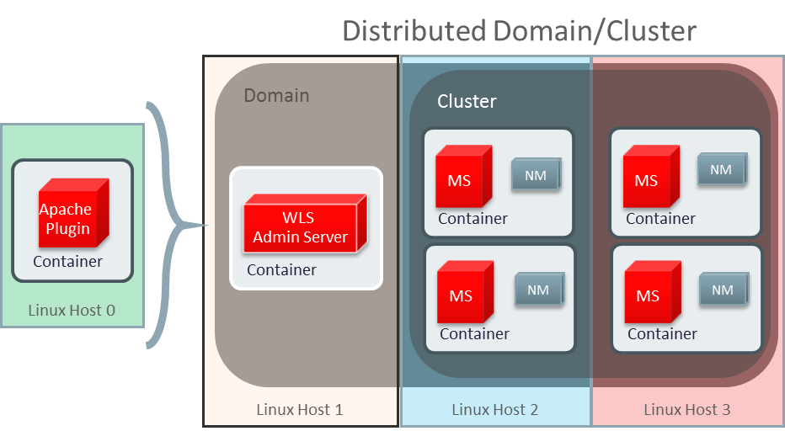

Fig 6. Distributed Oracle WebLogic Server Domain or Cluster with Load Balancing Tier

Additional Considerations Running Oracle WebLogic Server with Docker
- Oracle WebLogic Server configuration, server logs, file stores etc are all kept in the container file system. When a Docker container is destroyed you will lose your entire file system. There are two alternatives to this:
  - Use the host file-system to store the container’s local file system.
  - Maintain a “data-only” container to store your domain file system.
To minimize the dependency on the file system we recommend:
  - Keep your stores such as TLog and JMS stores in the database
  - If you do XA Transactions use the “XATransactions without TLog Write”, this minimizes the writing to the TLog.
Fig 7. Oracle WebLogic Server on Docker Data Volume in Container or Host

- To patch or upgrade your Oracle WebLogic Server images created with the Oracle WebLogic Server generic installation image, follow the following steps:
- Upgrade/patch by extending the Oracle WebLogic Server install Docker image.
- Use the Docker cp (copy) command to copy your domain folder to destination either the host or a “data-only” container
- Remove Container
- Run new container from extended image (with upgrade/patch).
- Use the Docker cp (copy) command to copy back your domain folder to the upgraded container
- Security concerns have been raised regarding Docker and Linux containers.
  - One area of concern is whether it is possible to isolate code running in separate containers from each other. There are no known issues impacting the ability to run Oracle WebLogic Server in such an environment at this time.
  - Another area of concern with respect to security is the source of Docker images. One should only obtain Docker images from trusted sources and one needs to be aware of the frequency of updates and the nature of the controls on Docker Hub.
  - Customers should stay current with Docker and Linux technology and remain aware of security issues that are raised in each.
  - Docker containers default network mode of “Bridge Networking” does not support multicast. Docker Containers “Host Networking” supports multicast but provides less isolation since it uses the host networking stack. We recommend the use of unicast as the Oracle WebLogic Server clustering protocol when running in Docker Containers.

Conclusion
Docker technology offers the promise of simplifying operations and reducing cost due to the portable characteristics of its artifacts and ease of distribution across Linux environments. Oracle has responded to the growing interest of our customers by certifying Oracle WebLogic Server to run in Docker containers, and by providing images, Dockerfiles, and scripts that support the creation of Oracle WebLogic Server configurations running in Docker containers. We hope these are useful, and will seek to improve the scope of our support for Docker environments over time.

 | Oracle Corporation, World Headquarters Worldwide Inquiries  500 Oracle Parkway Phone: +1.650.506.7000  Redwood Shores, CA 94065, USA Fax: +1.650.506.7200
Connect with us   blogs.oracle.com/oracle   facebook.com/oracle   twitter.com/oracle   oracle.com  Connect with us  blogs.oracle.com/oracle  facebook.com/oracle  twitter.com/oracle  oracle.com  Connect with us  blogs.oracle.com/oracle  facebook.com/oracle  twitter.com/oracle  oracle.com | Copyright © 2014, Oracle and/or its affiliates. All rights reserved. This document is provided for information purposes only, and the contents hereof are subject to change without notice. This document is not warranted to be error-free, nor subject to any other warranties or conditions, whether expressed orally or implied in law, including implied warranties and conditions of merchantability or fitness for a particular purpose. We specifically disclaim any liability with respect to this document, and no contractual obligations are formed either directly or indirectly by this document. This document may not be reproduced or transmitted in any form or by any means, electronic or mechanical, for any purpose, without our prior written permission.  Oracle and Java are registered trademarks of Oracle and/or its affiliates. Other names may be trademarks of their respective owners.  Intel and Intel Xeon are trademarks or registered trademarks of Intel Corporation. All SPARC trademarks are used under license and are trademarks or registered trademarks of SPARC International, Inc. AMD, Opteron, the AMD logo, and the AMD Opteron logo are trademarks or registered trademarks of Advanced Micro Devices. UNIX is a registered trademark of The Open Group. 0516  Oracle WebLogic Server on Docker Containers  April 2016  Monica Riccelli WebLogic Server PM  Bruno Borges Technical Advisor  

