
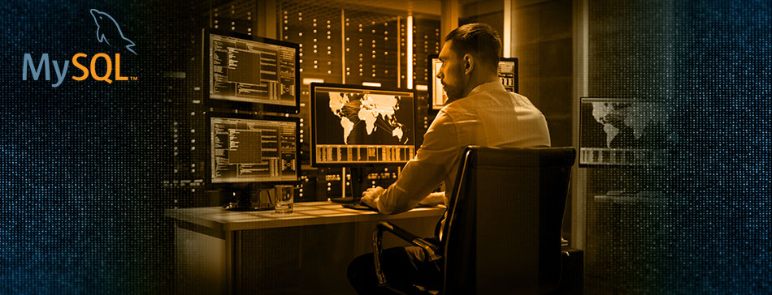

The global average cost of a data breach has risen 12 percent over the past five years to $3.92 million according to the Ponemon Institute's 2019 Global Study
If you are currently using MySQL Community Edition, how will you address the growing threat of a security breach?
That’s Where MySQL Enterprise Edition Comes In
MySQL Enterprise Edition includes one of the most comprehensive sets of advanced features, management tools and technical support to achieve the highest levels of MySQL scalability, security, reliability, and uptime. It reduces the risk, cost and complexity in developing, deploying, and managing business-critical MySQL applications.
WATCH DEMO

{ Partner Value Proposition }
{Partner Display Name}
{1-999-999-9999}
{Partner Website}


Terms and Conditions | Privacy Policy
View in Browser • Unsubscribe • Copyright © 2019 - All rights reserved.

