

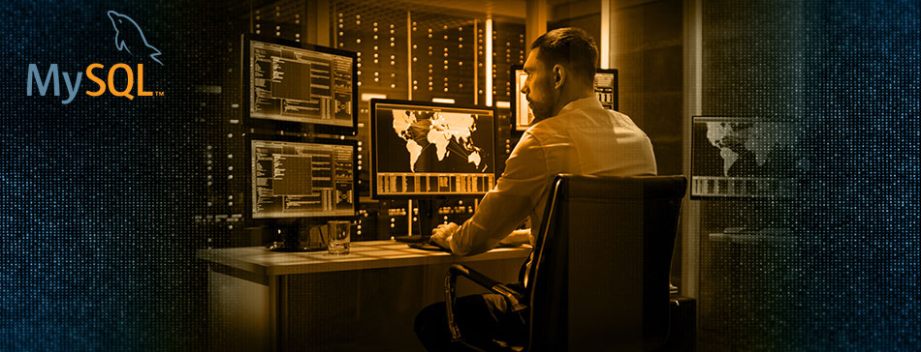

Integrate security practices within DevOps with MySQL Enterprise Edition
Modern software products are not created in isolation. It is likely that most will include some open source software, like MySQL Community Edition. But one must ask themselves:
- How will you address privacy, security, and compliance with the freely downloadable and open source MySQL Community Edition?
- What database product will provide me with the tools to efficiently and securely deliver new, innovative software?
Enter MySQL Enterprise Edition
MySQL Enterprise Edition enables you to:
- Help automate security throughout the development process, from the design of the application to its production with a rich set of enterprise security features like MySQL Enterprise Firewall, Encryption, Authorization, and more!
- Meet the sustained performance and scalability requirements of ever increasing user, query and data loads with MySQL Enterprise Scalability
- Get real-time visibility into the performance, availability, health, activity, and history of all your databases through MySQL Enterprise Monitor
For more information, check out this presentation on MySQL EE Best Practices:
Download Now

{ Partner Value Proposition }
{Partner Display Name}
{1-999-999-9999}
{Partner Website}


Terms and Conditions | Privacy Policy
View in Browser • Unsubscribe • Copyright © 2019 - All rights reserved.

