Oracle Enterprise and Cloud Manageability
Virtual Classroom Series

  - Virtual Classroom 5: Detect, Protect and Predict
Questions & Answers
November 12 2020 | Version 1.05
Copyright © 2020, Oracle and/or its affiliates
Public

Purpose Statement
This document provides a list of Questions and Answers retrospective to the Enterprise and Cloud Manageability Virtual Classroom Webinar Series.

Disclaimer
This document is for informational purposes only and is intended solely to assist you in deploying and using the product features described. It is not a commitment to deliver any material, code, or functionality, and should not be relied upon in making purchasing decisions. The development, release, and timing of any features or functionality described in this document remains at the sole discretion of Oracle.

Table of Contents
Purpose Statement 2
Disclaimer 2
QUESTIONS & ANSWERS 4
Do we need to have the database running in the Oracle Home used for Gold Image? 4
During one off patching, will EM Fleet Maintenance take care of wallet files placed in the Oracle Home? 4
In EM Fleet Maintenance, when we patch using the Gold Image, the Oracle Home path will change to a new location? Is this correct? 4
Does Oracle have plans in the future to run EM Fleet Maintenance from EM GUI as we had for prior version 12.1 rather than using command line? 4
How Does EM Fleet Maintenance rollback the catalog changes done in the database? Does it use FRA to rollback? 4
When using EM Fleet Maintenance, what will happen to the tnsnames.ora? Will it automatically be copied to the new home? 5

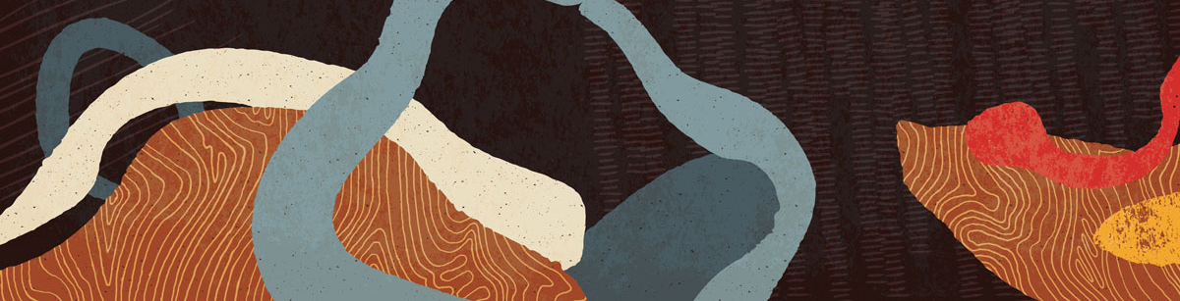

QUESTIONS & ANSWERS

Do we need to have the database running in the Oracle Home used for Gold Image?

No. Oracle Home does not need to have the database running.

During one off patching, will EM Fleet Maintenance take care of wallet files placed in the Oracle Home?

Yes. This was answered during the Webinar Session
(Please watch the On-Demand Video for the answer)

In EM Fleet Maintenance, when we patch using the Gold Image, the Oracle Home path will change to a new location? Is this correct?

Yes. This was answered during the Webinar Session
(Please watch the On-Demand Video for the answer)

Does Oracle have plans in the future to run EM Fleet Maintenance from EM GUI as we had for prior version 12.1 rather than using command line?

Yes, we will be releasing Fleet UI as part of EM 13.4 release update coming out early next calendar year.

How Does EM Fleet Maintenance rollback the catalog changes done in the database? Does it use FRA to rollback?
This was answered during the Webinar Session
(Please watch the On-Demand Video for the answer)

When using EM Fleet Maintenance, what will happen to the tnsnames.ora? Will it automatically be copied to the new home?
This was answered during the Webinar Session
(Please watch the On-Demand Video for the answer)

If a wallet file location is defined in sqlnet.ora will it change the file location after migration?

This was answered during the Webinar Session
(Please watch the On-Demand Video for the answer)

Please also refer to the EM documentation library:
https://docs.oracle.com/en/enterprise-manager/cloud-control/enterprise-manager-cloud-control/13.4/emlcm/database-fleet-maintenance.html#GUID-785D23CB-A459-42CF-8992-4D83BE9F82EC

Can we rollback after running clean-up operation in of previous home in FM? Or do we only rollback if the previous Oracle Home exist?

We can only rollback if previous Oracle Home exists , usually clean-up is done couple of months after patching

Does CIS Compliance checking require additional license i.e. is it an EM option / pack that needs to be purchased?

Compliance, Fleet Maintenance and Provisioning and Cloning are all part of Database Lifecycle Management pack.
Please see the following reference:
https://www.oracle.com/manageability/enterprise-manager/technologies/database-lifecycle-management-pack.html

How does newer/updated versions of CIS rules get uploaded to EM/Agent?

This was answered during the Webinar Session
(Please watch the On-Demand Video for the answer)
CONNECT WITH US
Call +1.800.ORACLE1 or visit oracle.com.
Outside North America, find your local office at oracle.com/contact.
 |  | blogs.oracle.com |  | facebook.com/oracle |  | twitter.com/oracle
 | Copyright © 2020, Oracle and/or its affiliates. All rights reserved. This document is provided for information purposes only, and the contents hereof are subject to change without notice. This document is not warranted to be error-free, nor subject to any other warranties or conditions, whether expressed orally or implied in law, including implied warranties and conditions of merchantability or fitness for a particular purpose. We specifically disclaim any liability with respect to this document, and no contractual obligations are formed either directly or indirectly by this document. This document may not be reproduced or transmitted in any form or by any means, electronic or mechanical, for any purpose, without our prior written permission.
 |  |  |  |  |  |  | 

