Customizing Resource Forms

Summary
Resource Forms are used during access request, approval, and fulfillment and to view account details. This note describes how resource forms can be customized to achieve customer requirements. In this note, a disconnected application is created and its forms customized.

Use Cases covered in this note
- Form fields should be shown only during fulfillment
- Some Form fields should be hidden during request
- Some form fields should be shown during approval

Pre-requisites
- Some knowledge of EL Expressions
- OIM Developer Guide – UI Customization chapters

Steps
- Login to the /sysadmin conole
- Create a sandbox
- Create a disconnected application instance, say, ASIC
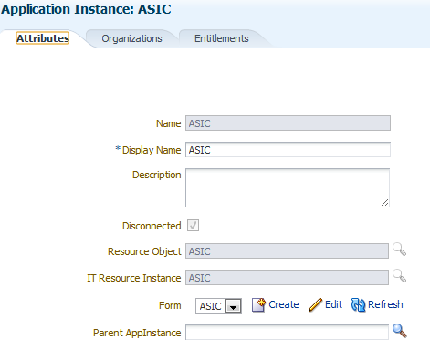
- Once the application instance has been created, edit the default form

- Add a Text attribute called Factory ID. Note: You can skip this step if you want to
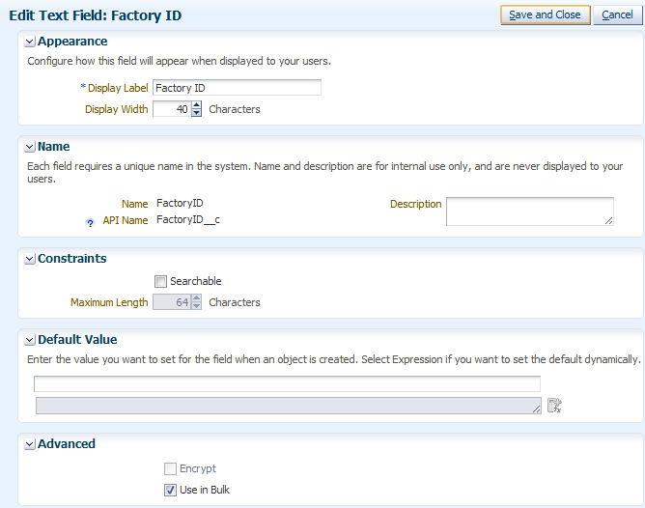
- Click Regenerate View. This step is required since we extended the schema of the application instance and now need that attribute to be added to the UI as well.
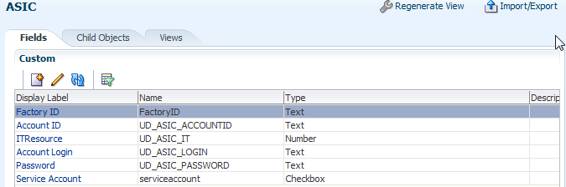

- Click Import/Export
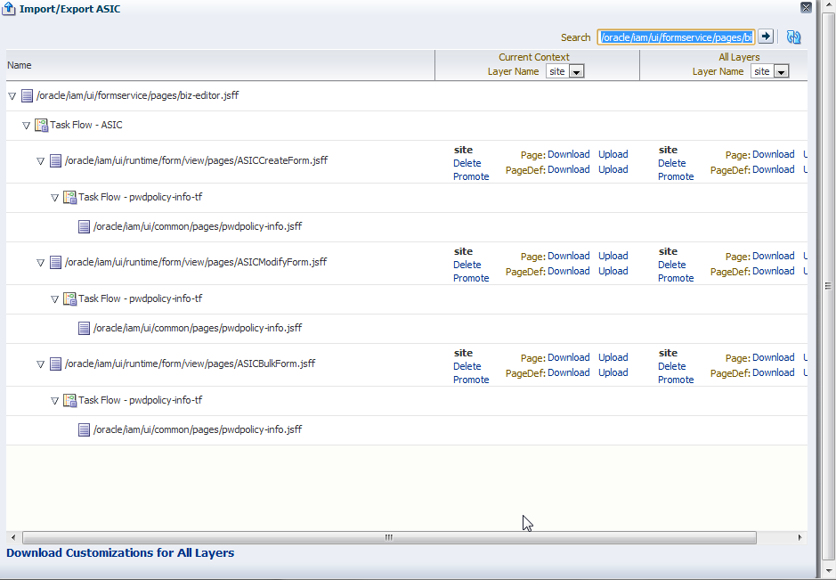
- We are interested in modifying the following forms
Form | Usage
Create | New account request
Modify | Approval, Modify account, Fulfill

- Download the Create and Modify and Forms
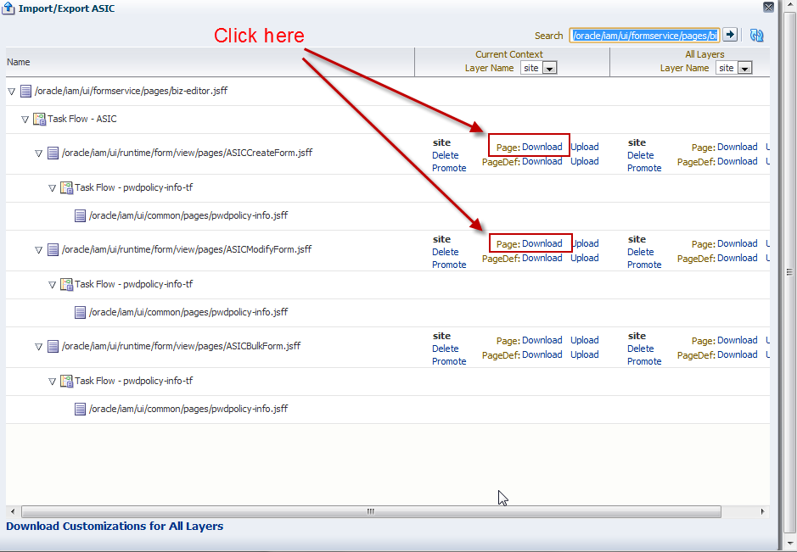
- There are two session variables available to us:
  - requestformcontext
  - oimusercontext
These variables and the properties that they expose are documented in Section 30.12.1 of the Developer Guide for Oracle Identity Manager
- Open the Create Form in your favorite text editor
  - To hide the password field during approval and while viewing the account details (and this applies to any attribute), see the following snippet
<af:panelLabelAndMessage xmlns:af="http://xmlns.oracle.com/adf/faces/rich"
rendered="#{pageFlowScope.requestFormContext.actionType == 'SUMMARY' or pageFlowScope.requestFormContext.actionType == 'APPROVAL' and pageFlowScope.requestFormContext.operation != 'CREATE'}"
label="#{bindings.UD_ASIC_PASSWORD__c .hints.label}" id="_xg_2">
<af:inputText xmlns:af="http://xmlns.oracle.com/adf/faces/rich" value="#{bindings.UD_ASIC_PASSWORD__c .inputValue}"
required="#{bindings.UD_ASIC_PASSWORD__c .hints.mandatory}" columns="#{bindings.UD_ASIC_PASSWORD__c .hints.displayWidth}"
maximumLength="#{bindings.UD_ASIC_PASSWORD__c .hints.precision}" shortDesc="#{bindings.UD_ASIC_PASSWORD__c .hints.tooltip}"
rendered="#{pageFlowScope.requestFormContext.actionType != 'SUMMARY' and pageFlowScope.requestFormContext.actionType != 'APPROVAL' and pageFlowScope.requestFormContext.operation != 'CREATE'}"
autoSubmit="true" simple="true" secret="true" id="_xg_3">
<f:validator xmlns:f="http://java.sun.com/jsf/core" binding="#{bindings.UD_ASIC_PASSWORD__c .validator}"/>
</af:inputText>
<f:facet xmlns:f="http://java.sun.com/jsf/core" name="end">
<af:commandImageLink xmlns:af="http://xmlns.oracle.com/adf/faces/rich" icon="/images/info.png" immediate="true" id="_xg_4">
<af:showPopupBehavior xmlns:af="http://xmlns.oracle.com/adf/faces/rich" popupId="pwdpolicyInfo" triggerType="action"/>
</af:commandImageLink>
</f:facet>
</af:panelLabelAndMessage>
  - To secure the password field so that only a system administrator can modify it, you can add the following check
#{oimcontext.currentUser.adminRoles['OrclOIMSystemAdministrator'] != null}

to the EL expression shown above
- Similarly, modify the Modify form.
- Save your changes
- Return to application instance and click Import/Export
- Upload the files by clicking the Upload link next to the respective files.

