CERTAIN NEW IN-PERSON EVENT CONTENT SUBMISSION TEMPLATE - LIGHTBOX REGISTRATION FORM

This request is to create a landing page for mid-sized In-person events. Event name: Certain New In-Person Event Template
Event code: Certain-New-Template
URL: https://eventreg.oracle.com/profile/web/index.cfm?PKwebID=0x909645abcd

PRIMARY MODULE:
(Note: 1. It can accommodate either an image/video or a full width image. (1921 × 361px)
- Banner can either be pillar colors, AI or any custom image)
- Thumbnail image (380*254)
- Video link (Supports only YouTube videos)
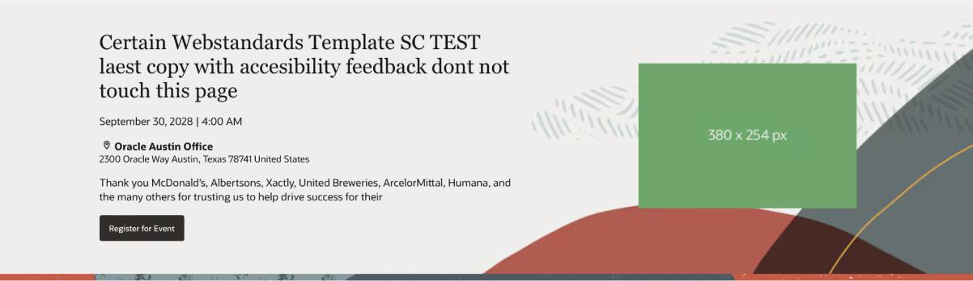

Event Title - Event title lorem ipsum
(Note: Event Name: About 5 words approximately and not more than 2 lines.)

Date and Time - July 8, 2024 | 12:00 Noon PDT
Location - 100 Oracle Pkwy, Redwood City, CA 94065
(Note – Hyperlink the address, on click user will be redirected to maps.)

Event description - Lorem ipsum dolor sit amet, consectetur adipisicing elit, sed do eiusmod tempor incididunt ut labore et dolore magna aliqua.
Registration CTA – Register for Event

OVERVIEW MODULE:
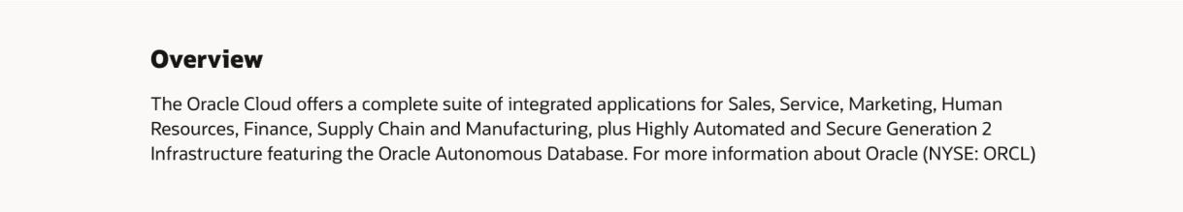

Overview title - Overview section
Description - Eillum dolore eu fugiat nulla pariaest laborum. Lorem ipsum dolor sit amet, consectetur adipisicing elit.

COUNTDOWN TIMER MODULE:
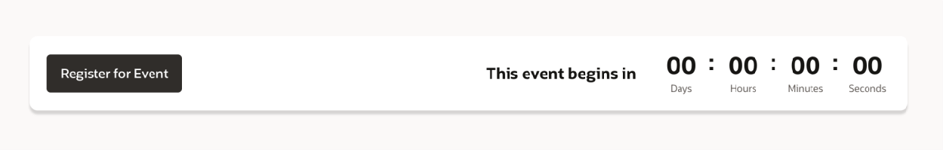

Registration button – Register for Event

AGENDA MODULE:
(Note - This module will have a tab option if it’s a multiday event, and a single section for single day event.)
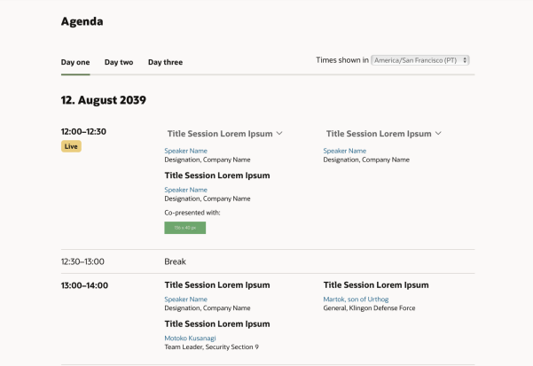
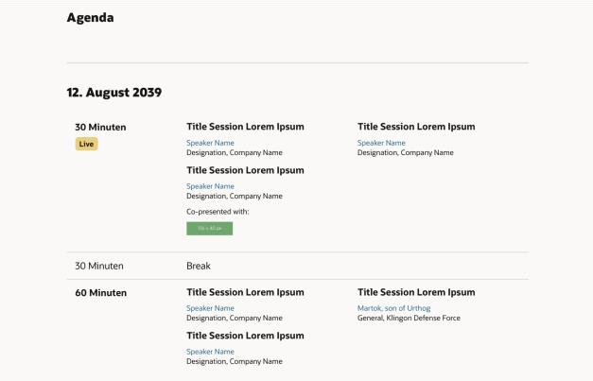

Title – Agenda

Day one tab:

Date – 15 August 2026

Date & time - 28, July 2023 Session Time - 13:00 – 13:40 Session title - Keynote OCW
Session speaker - John Doe (Note: Hyperlinking the text is optional)

Day Two tab:

Date – 15 August 2026

Date & time - 29, July 2023
Session Time - 15:00 – 15:40
Session title - Learning sessions, hands-on labs, tutorials, certifications, lightning sessions
Session speaker – Xavier (Note: Hyperlinking the text is optional)

FEATURED SPEAKER MODULE:
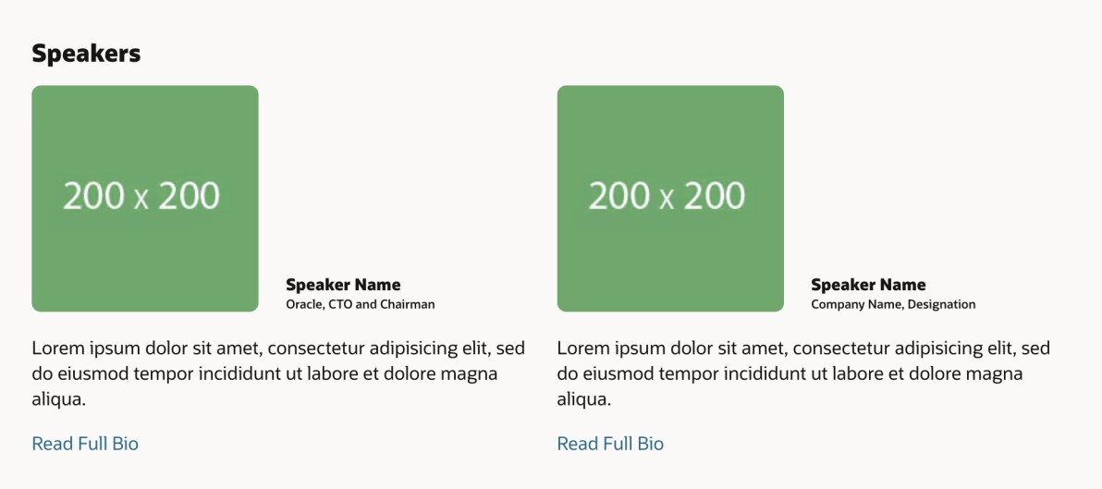
Title – Featured Speakers

Thumbnail image (200*200px)

Speaker’s name - John Doe

Speaker’s Job Title - Oracle, CTO and chairman
Speaker’s bio short - West laborum Lorem ipsum dolor sit amet, consectetur adipisicing elit, sed do eiusmod tempor incididunt ut labore et dolore magna aliqua.

Speaker bio lightbox - Ut enim ad minim veniam, quis nostrud exercitation ullamco laboris nisi ut aliquip ex ea commodo consequat. Duis aute irure dolor in reprehenderit in voluptate velit esse cillum dolore eu fugiat nulla pariatur.

SPONSOR MODULE:
(This module is optional.)



Sponsor module title - OCW is co-sponsored by

Sponsor logo
(Note – logo images will auto resize)

CONTACT SECTION MODULE:
(This module is optional.)
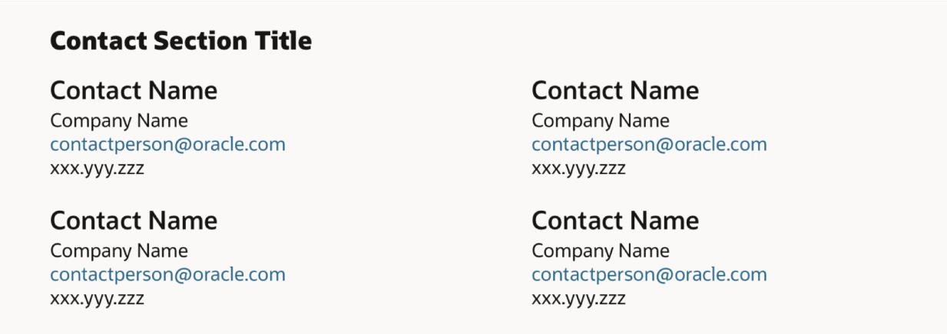

Title – Contact Us
Contact name – Bill Rundle

Contact Title – HR

Email id – bill@abcd.xyz
Contact number – 090909090.

FAQ MODULE:
(This module is optional.)

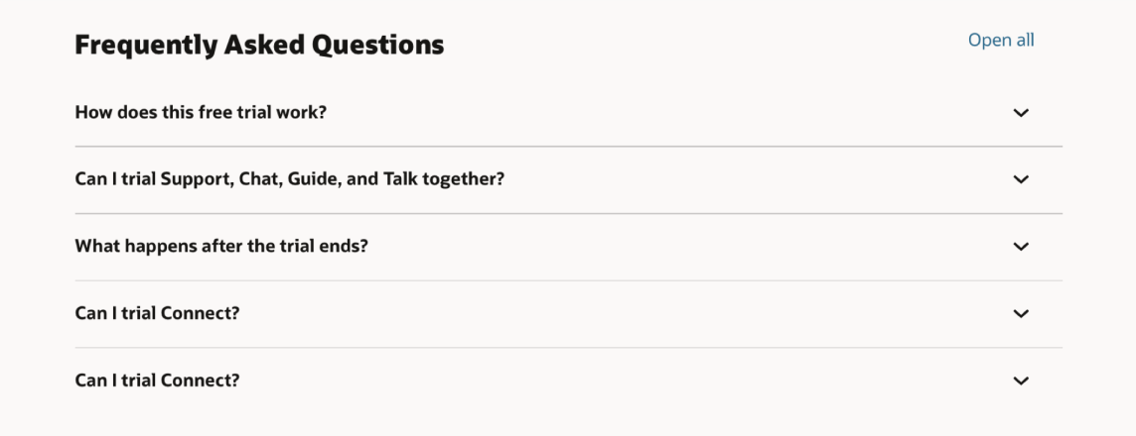

FAQ title - Frequently asked Questions

Question 1 - How does this free trial work?

Answer 1 - Lorem ipsum dolor sit amet, consectetuer adipiscing elit. Donec odio. Quisque volutpat mattis eros.

STICKY NAVIGATION MODULE:
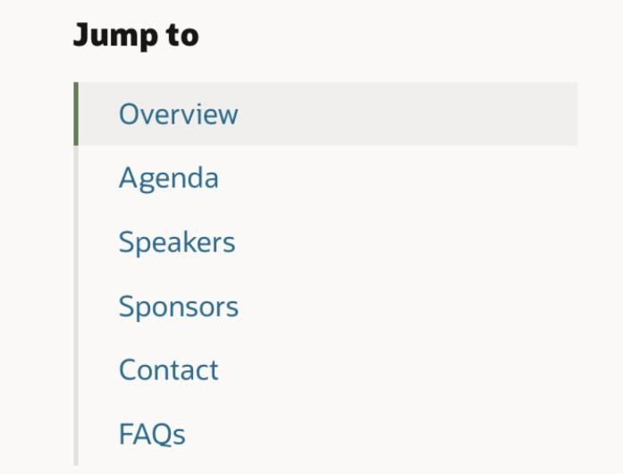
Sticky Nav title - Jump to

Module 1 – Overview

Module 2 – Agenda

SHARE MODULE:

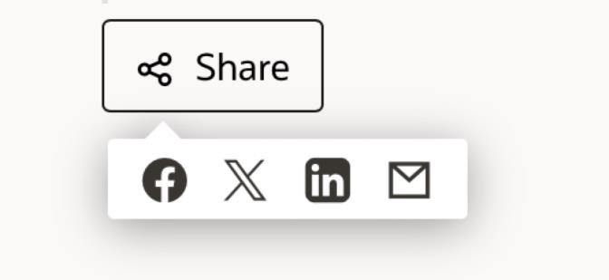

Share Title – Share

Social media 1 – Facebook

Social media 2 – Twitter

DISCLAIMER MODULE*:

EVENT PROMOTIONAL MODULE*:
