ZOOM MULTI-REG WEBINAR SERIES – CONTENT TEMPLATE

This request is to create Zoom Multi-Reg Webinars page having one landing page promoting multiple zoom live and on-demand webinars. Each webinar has its own registration form. NOTE: We cannot support a mixture of Zoom Meetings and Zoom Webinars. They need to be either all Meetings or all Webinars.

PROGRAM CODE STRATEGY:
One program code for the landing page that hosts the whole series and distinct program codes for each of the webinar.
- Landing Page program type = Digital-Microsite
- Zoom Live Webinar program type = EV-Seminar
- Zoom On-Demand Webinar program type = EV-Seminar

LP Program Details:
- MRM Program Code:
- MRM Program Name:

Request Details:
- Request Type = LPD (Create Landing Page)
- Request Number = TBC after submission

LANDING PAGE:

Banner Section
- Banner Dimension: 1923 px X 300 px
- Banner Title Text: About 5 words approximately and not more than 2 lines
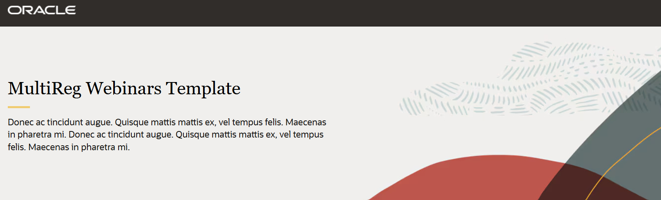
- Overview Content Section:

Enter webinar series brief here
Recommend 5-6 lines

- Tab Layout:

- Tab 1 : Tab title
- Tab 2 : Tab title
- Tab 3 : Tab title
- Tab 4 : Tab title

Note: This could be used for multiple pillars or for live & on-demand webinars. If multiple tabs are used, the live and on-demand webinars sections will be in the same page.

Webinar #1 Details:

Program Code:
Webinar Type: Live or On-Demand
Registration Type: Standard or Monitored
Webinar Title:
Zoom ID:
VideoHub Link (for On-Demand):

Webinar Thumbnail Image: file name
Dimension = 432px × 200px
Images are to be provided for all or none of the webinars for consistency.

- Read More Section (Popup)

- Overview:

- Webinar Title:

- Date (not required for On-Demand):

- Start Time (not required for On-Demand):

- Duration: xx mins

Description:

Speakers’ Section (Optional):

Speaker 01 Details:

Speaker Picture (200px x 200px): File Name
Speaker Name:
Speaker Job Title:
Speaker Biography:
Speaker Social Links:

- Template Builder Asset Details:
- Asset ID for Post Event Email Thank You:
- Asset ID for Post Event Email No Show:
- Asset ID for Pending Email (if Registration Type is Monitored):

Duplicate the Webinar/Meeting #1 Details for each event in your series.

