
Invoice Sequencing and VAT Reporting for Saudi Arabia

Financials for EMEA
ERP cloud

Table of Contents
1. Purpose of the document 2
2. Introduction 3
Document Sequence 3
Payables 4
Receivables 4
3. Assumptions and Prerequisites 5
4. Common Setup 6
Ledger Options 6
Tax Zone Type 7
5. Common Setup 8
Tax Regime 8
Tax Rates and Recovery Rates 9
Legal Reporting Unit Tax Registration 13
6. Payables and Receivables Documents Setup 15
Payables Document Categories 15
Receivables Transaction Types 17
7. Documents Sequencing Setup 19
Document Sequences 19
8. VAT Reporting Setup 23
Tax Reporting Configuration tab 23
9. VAT Reporting Submission 29
Transactions Extraction 29
Sales VAT Register 30
Purchase VAT Register 31
10. Examples of VAT Register Layout 32
Example of Receivables Sales VAT Register for Italy 32
Example of Purchase VAT Register for Italy 33

Purpose of the document
This document describes how reporting for VAT in Saudi Arabia can be modelled after reporting for VAT in Italy:
- Enable document sequencing on commercial documents
- Enable a VAT reporting that helps businesses to justify and prepare VAT returns. The main objective is an automatic reconciliation on Tax Codes using the Italian Purchase and Sales VAT Registers based on Document Sequencing
Note
- This document is not intended to provide a turnkey configuration for Saudi Arabia; customers must adapt and tailor the suggested approaches to their own business
- This document mentions ‘for Italy’ in few instances. Reason: The VAT Reporting described in this document is based on standard features and localization features for Italy, which provide a fit to meet the VAT reporting requirements for Saudi Arabia

Introduction
Enabling the document sequencing feature in conjunction with the use of Tax reporting configuration and Tax registers allows users to:
- Comply with the gapless sequencing
- Aid VAT reporting for preparation of the VAT return and reconciliation
Hereafter, is a brief description of sequencing features and their applicability in Payables and Receivables architecture.

Document Sequence
The Document Sequence uniquely numbers documents such as purchases invoices or sales invoices entered in Payables and Receivables.
The Document Sequence can number documents in a number of ways:
- Automatic: the system assigns the sequence number automatically to documents by data/time of creation. Note that with the Automatic option, numbering sequence numbers can be lost due to incomplete or failed document creation.
- Gapless: the system assigns the sequence number automatically to documents when successfully generated. The Gapless numbering option ensures that no sequence numbers are lost due to incomplete or failed document creation.
- Manual: user assigns the sequence number manually when creating the document. The manual numbering option does not allow numeric ordering because users can skip or omit numbers when entering the number.
The Document Sequence numbering starts from 1; the Start Date is mandatory whereas the End Date is optional. Based on country needs, the Document Sequence can be setup as follows:
- Monthly Period Frequency: enter the Start Date 1/1/YYYY and End Date 1/31/YYYY
- Bi-Monthly Period Frequency: enter the Start Date 1/1/YYYY and End Date 2/28/YYYY
- Quarterly Period Frequency: enter the Start Date 1/1/YYYY and End Date 3/31/YYYY
- Yearly Periodic Frequency: enter the Start Date 1/1/YYYY and End Date 12/31/YYYY
- No Periodic Frequency: enter the Start Date 1/1/YYYY and End Date leaves blank.
See section 6. Documents Sequencing Setup how to setup a Document Sequence.
Additionally, three Sequencing options can be setup at Primary Ledger definition:
- Sequence By: Legal Entity; in such case, all document sequence numbering is assigned per Legal Entity
- Enforce Document Sequencing: Receivables and Payables; in such case the document sequence numbering is required for Receivables and Payables documents
- Enforce Chronological Order on Document Date: Yes. In such case, there must be a correlation between the document sequence number and transaction accounting date. This correlation prevents from creating a payable invoice or receivable transaction with an accounting date that is earlier than the accounting date of the last sequenced document within the same document sequence.
- Example: The document sequence number 1 is assigned to a Receivable transaction with accounting date of 2-Jan-2017. The document sequence number 2 is assigned to next Receivable transaction if the accounting date is 2-Jan-2017 or later. The document sequence number 2 is not assigned to the next Receivable transaction if the accounting date is earlier than 2-Jan-2017.
See section 4. Common Setup how to setup Ledger Sequencing Options.

Payables
Invoices, which share the same characteristics can be entered under the same Document Category. Example: domestic purchases can be entered under the Document Category named ‘Domestic Purchases’; import purchases can be entered under the Document Category named ‘Import Purchases’, etc. .
See section 5. Payables and Receivables Documents Setup how to setup a Document Category.
In order to number documents entered under the Document Category, a document sequence must be assigned to the Document Category to start with and can be reset at the beginning of the year for example.
See section 6. Documents Sequencing Setup how to setup a Document Sequence.

Receivables
Transactions, which share the same characteristics, can be entered under the same Transaction Type. Example: domestic sales can be entered under the Transaction Type named ‘Domestic Sales’; export sales can be entered under the Transaction Type named ‘Export Sales’, etc. .
See section 5. Payables and Receivables Documents Setup how to setup a Document Category.
In order to number the documents entered under the Transaction Type, a document sequence must be assigned to the Transaction Type to start with and can be reset at the beginning of the year for example.
See section 6. Documents Sequencing Setup how to setup a Document Sequence.

Assumptions and Prerequisites
In this document, it is assumed that the following key components are already set up, including:
- Geographies
- Accounting Calendars
- Chart of Accounts
- Primary Ledger
- Legal Entity
- Basic Tax setup and Tax rules
- Suppliers
- Customers
- Common Options for Payables and Receivables

Common Setup

Ledger Options
Task name: Specify Ledger Options
Implementation Project: FIN Implementation Project
Navigation: Navigator –> Setup and Maintenance -> Specify Ledger Options -> Sequencing
Screenshot – Sequencing Options setup
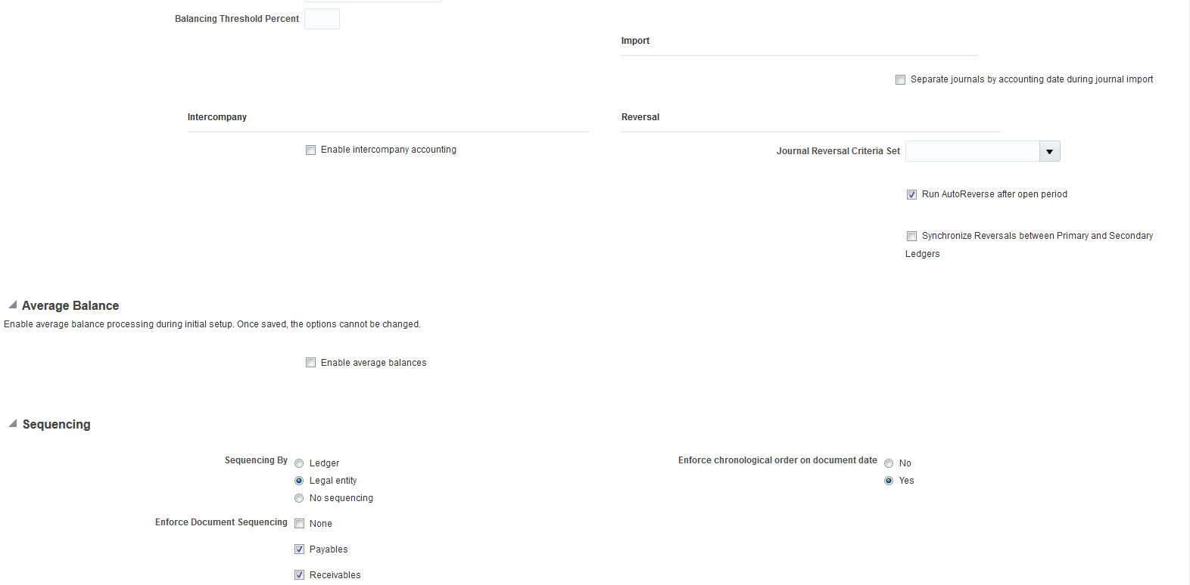

Tax Zone Type
Task name: Manage Tax Zone Types
Navigation: Navigator –> Setup and Maintenance -> Manage Tax Zone Types
Screenshot 1 – Query ‘Economic Region’ zone type, then click ‘Next’ button
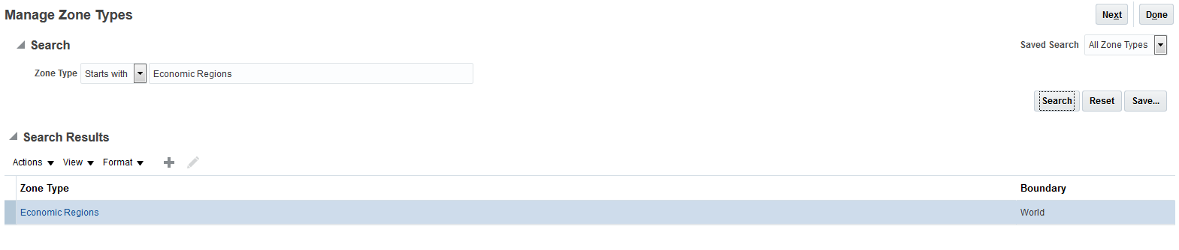Screenshot 2 – GCC Economic Region creation and Saudi Arabia and UAE Geography additions
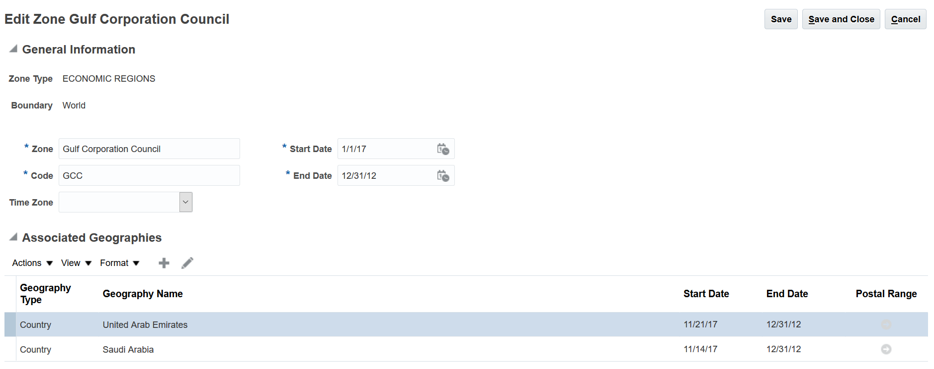
Then, add other GCC implementing countries when required.
Country | Geography Type | Geography Name
Bahrain | Country | Bahrain
Kuwait | Country | Kuwait
Oman | Country | Oman
Qatar | Country | Qatar

Tax Setup

Tax Regime
Task name: Manage Tax Regimes
Navigation: Navigator –> Setup and Maintenance -> Manage Tax Regimes
Enable ‘Use tax reporting configuration’ check box; this enables the Tax Reporting Configuration tab on the Create/Edit Tax Registration page, which is a pre-requisite for VAT Reporting.
Screenshot 1.a – Tax Regime creation
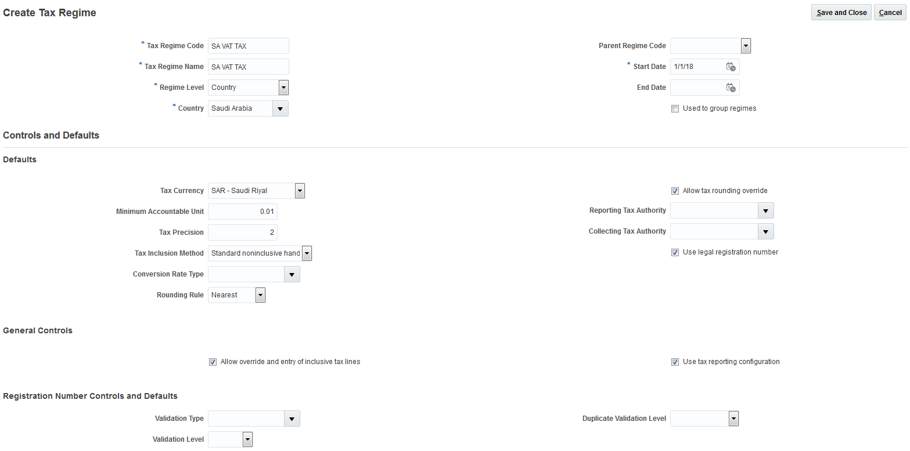

Tax Rates and Recovery Rates
Task name: Manage Tax Rates and Tax Recovery Rates
Navigation: Navigator –> Setup and Maintenance -> Manage Tax Rates and tax Recovery Rates
Rate Type: Tax Recovery Rates
Screenshot – Tax Rate Code ‘SA VAT TAX STANDARD REC RATE’ creation
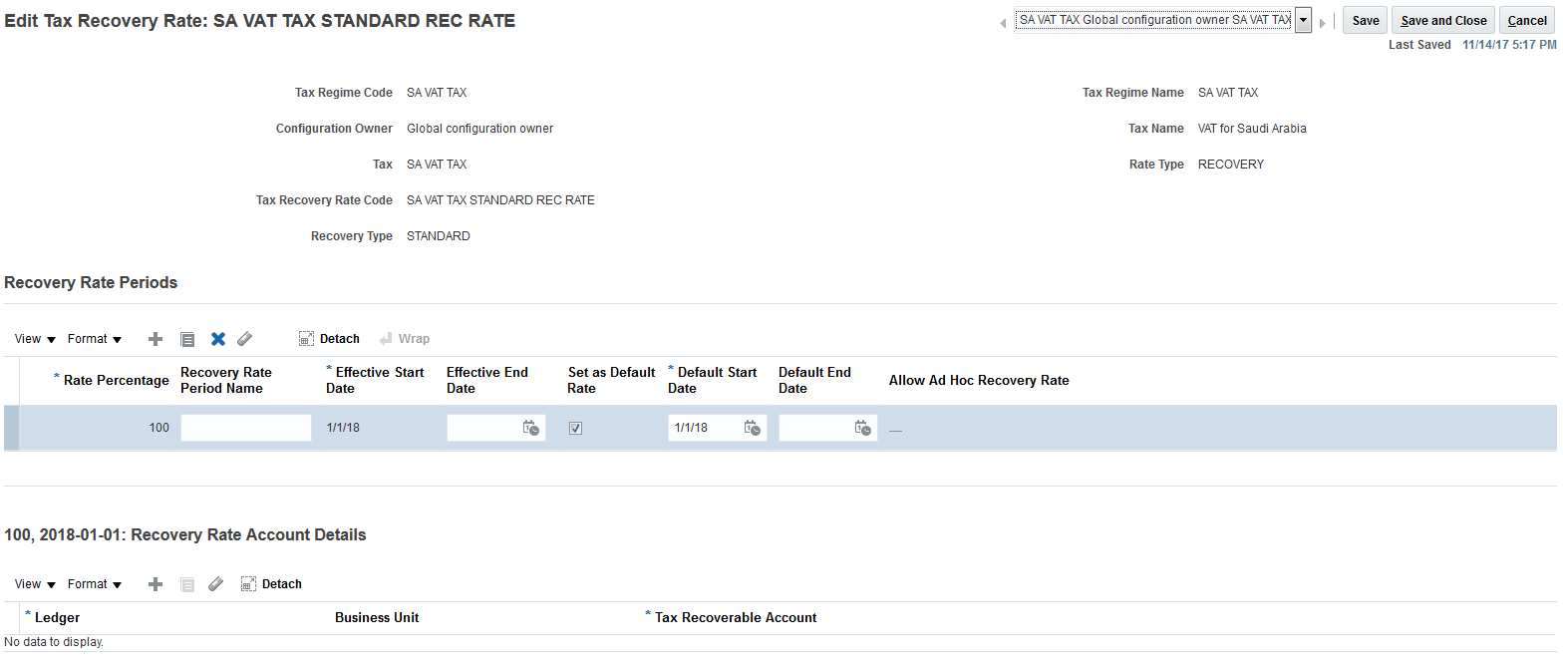

Task name: Manage Tax Rates and Tax Recovery Rates
Navigation: Navigator –> Setup and Maintenance -> Manage Tax Rates and tax Recovery Rates
Rate Type: Tax Rates
Screenshot – Tax Rate Code ‘SA VAT TAX STANDARD RATE’ creation: Main Details tab
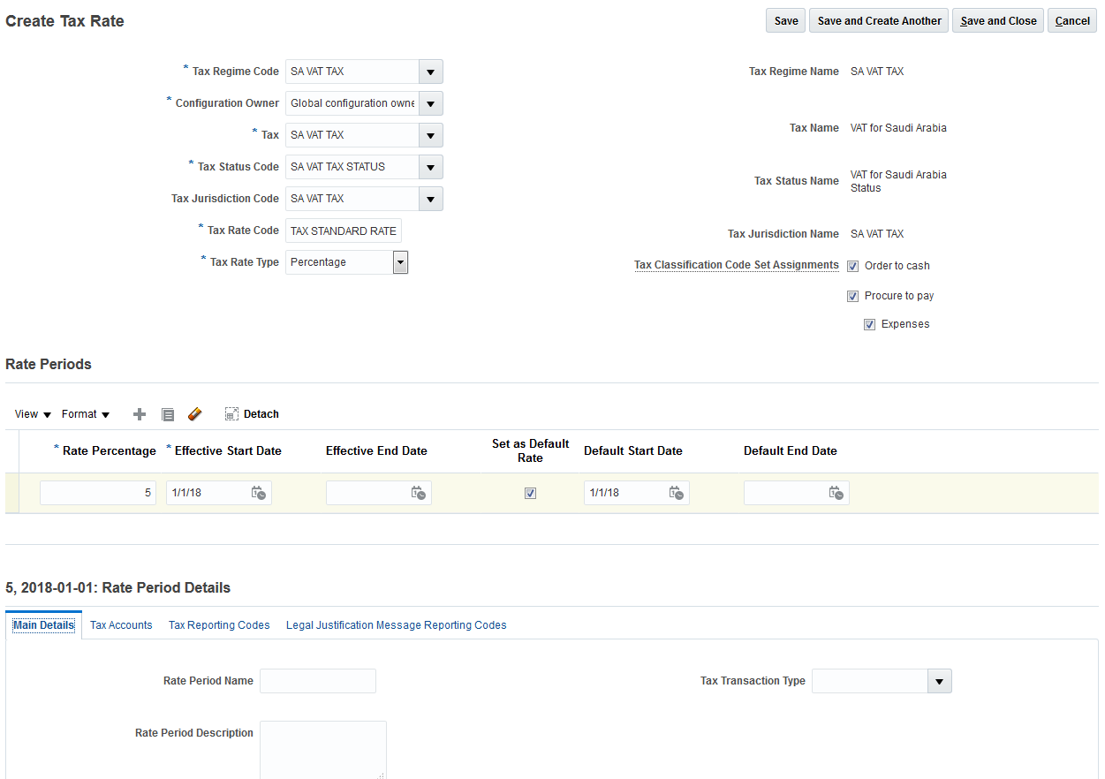

Screenshot–Tax Rate Code ‘SA VAT TAX STANDARD RATE’ creation: Main Details tab
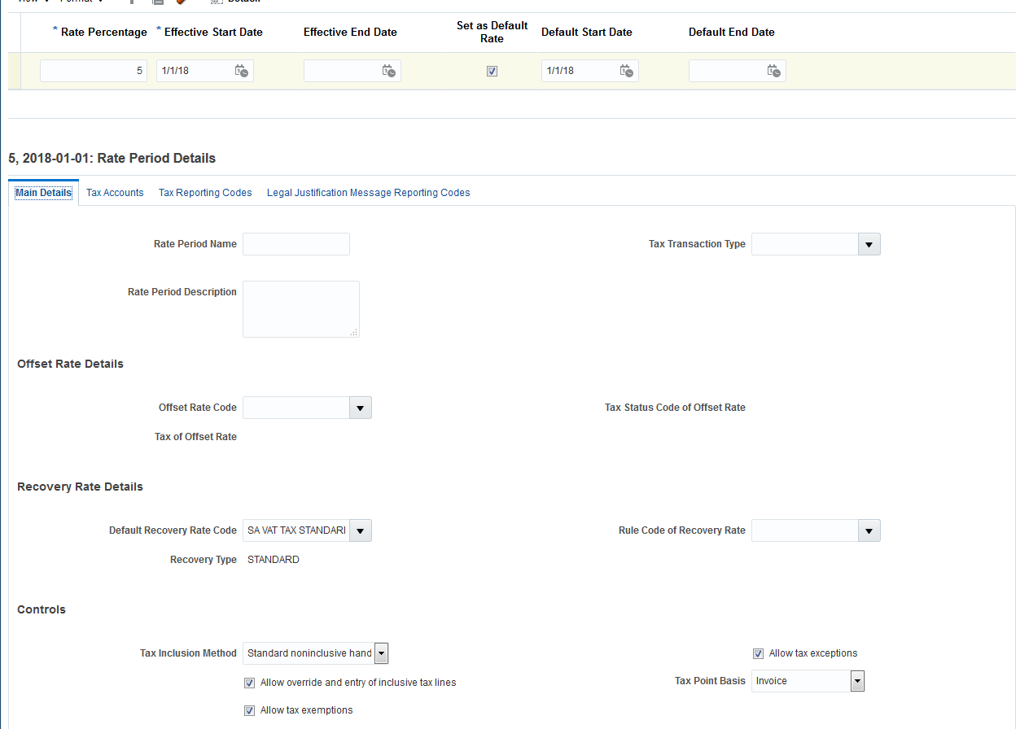

Screenshot – Tax Rate Code ‘SA VAT TAX STANDARD RATE’ creation
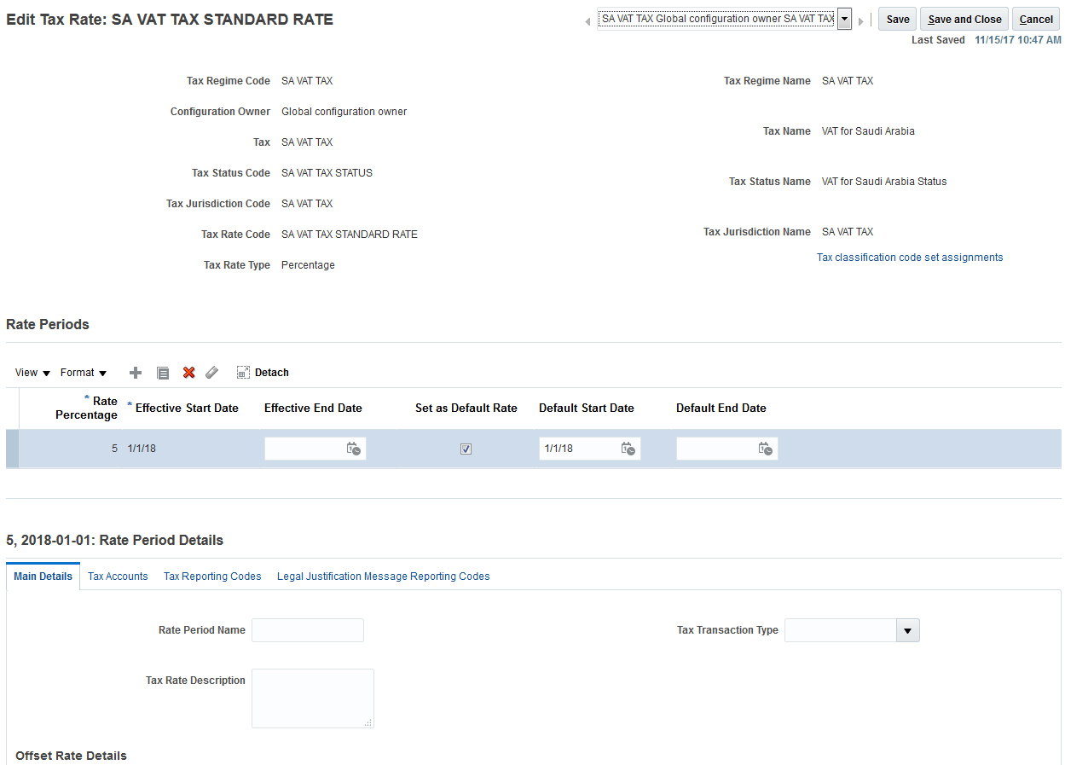

Suggested VAT Rate codes driven by the VAT return requirements:
Tax Rate Code | Tax Rate Name | Tax Rate
SA VAT TAX INTRA GCC | SA VAT TAX INTRA GCC GOODS | 0
SA VAT TAX EXEMPT RATE | SA VAT TAX INTRA GCC SERVICES | 0
SA VAT TAX STANDARD RATE | SA VAT TAX STANDARD RATE | 5
SA VAT TAX EXPORT ZERO RATE | SA VAT TAX EXPORT ZERO RATE | 0
SA VAT TAX ZERO RATE | SA VAT TAX ZERO RATE | 0
SA VAT TAX DEFAULT ZERO RATE | SA VAT TAX DEFAULT ZERO RATE | 0

Legal Reporting Unit Tax Registration
Task name: Manage Tax Registrations
Navigation: Navigator –> Setup and Maintenance -> Manage Tax Registrations
Create Legal Reporting Unit Tax Registration with the Registration Number, which is a mandatory component of the Tax Reporting Configuration.
Under General tab:
- Select ‘VAT’ for Tax Register Type
- Enter the Tax Registration Number for the Legal Reporting Unit Tax Registration;
- Select ‘Registered’ for Tax Registration Status.
Note
Tax Reporting Configuration tab will be setup later. See section 7. VAT Reporting Setup.
Screenshot 1 – Legal Reporting Unit Tax Registration creation: General tab
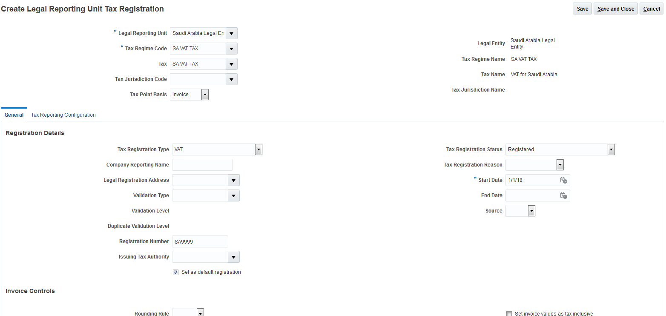

Screenshot 2 – Legal Reporting Unit Tax Registration creation: General tab
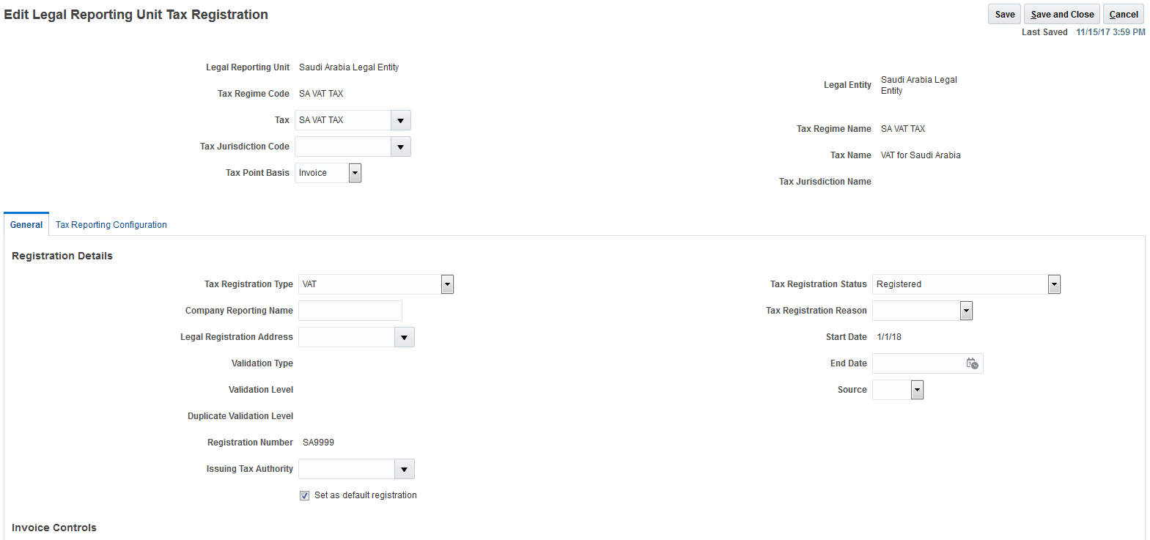

Payables and Receivables Documents Setup

Payables Document Categories
Task name: Manage Document Sequence Categories
Navigation: Navigator –> Setup and Maintenance -> Manage Document Sequence Categories
Screenshot 1 – ‘SA Standard rated domestic purchases’ creation
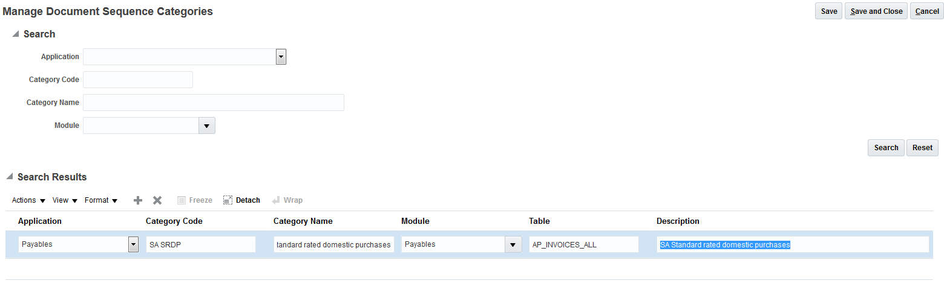

Screenshot 2 - ‘SA Standard rated domestic purchases’ creation
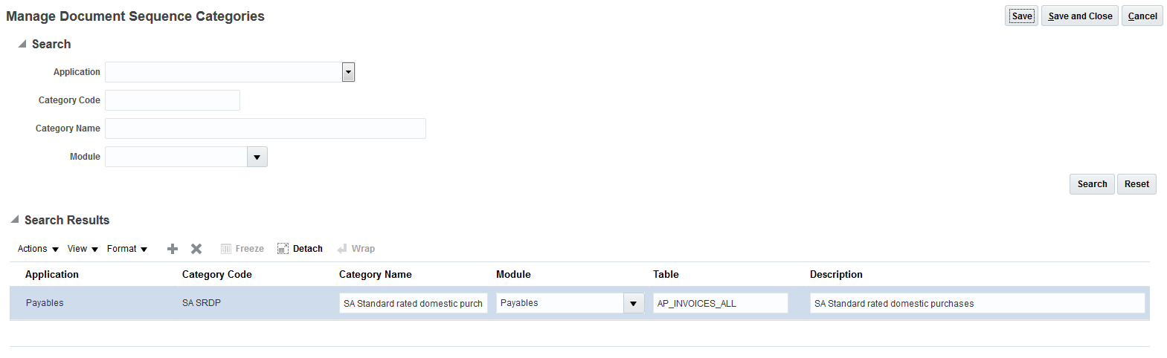

Create the Payables Document Categories; the below table is an example to be adapted to your own Business context.
Application | Category Code | Category Name | Module | Table | Description
Payables | SA SRDP | SA Standard rated domestic purchases | Payables | AP_INVOICES_ALL | SA Standard rated domestic purchases
Payables | SA ISC | SA Import subject to VAT paid at customs | Payables | AP_INVOICES_ALL | SA Import subject to VAT paid at customs
Payables | SA ISRC | SA Import subject to reverse charge | Payables | AP_INVOICES_ALL | SA Import subject to reverse charge
Payables | SA ZRP | SA Zero rated purchases | Payables | AP_INVOICES_ALL | SA Zero rated purchases
Payables | SA EP | SA Exempt purchases | Payables | AP_INVOICES_ALL | SA Exempt purchases

Note
Businesses organized under a group might want to isolate and verify intra-group purchases realized within their group of legal entities: this can be done by creating a specific additional category code.

Receivables Transaction Types
Task name: Manage Transaction Types
Navigation: Navigator –> Setup and Maintenance -> Manage Transaction Types
Screenshot 1 - ‘SA Standard rated domestic sales’ creation
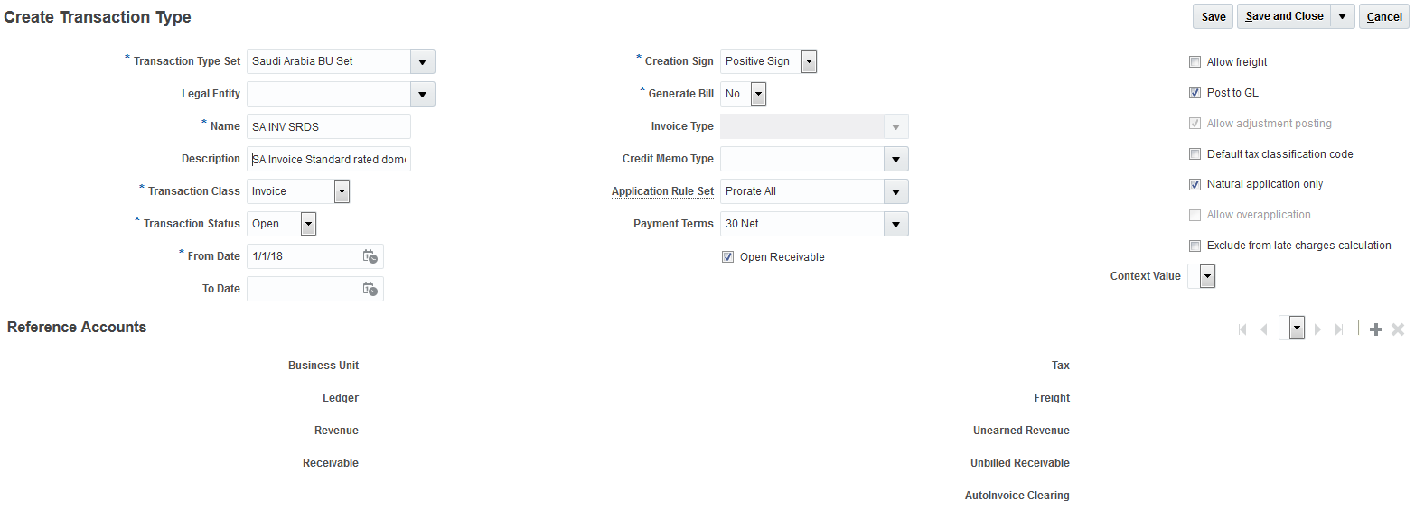

Create the Receivables Transaction Types; the below table is an example to be adapted to your own Business context.
Name | Description | Transaction Class | Creation Sign
SA INV SRDS | SA Invoice Standard rated domestic sales | Invoice | Positive Sign
SA CM SRDS | SA CM Standard rated domestic sales | Credit Memo | Negative Sign
SA INV SGCC | SA Invoice Sales to registered customers in other GCC states | Invoice | Positive Sign
SA CM SGCC | SA CM Sales to registered customers in other GCC states | Credit Memo | Negative Sign
SA INV ZRDS | SA Invoice Zero rated domestic sales | Invoice | Positive Sign
SA CM ZRDS | SA CM Zero rated domestic sales | Credit Memo | Negative Sign
SA INV ZREX | SA Invoice Zero rated exports | Invoice | Positive Sign
SA CM ZREX | SA CM Zero rated exports | Credit Memo | Negative Sign
SA INV ES | SA Invoice Exempt sales | Invoice | Positive Sign
SA CM ES | SA CM Exempt sales | Credit Memo | Negative Sign

Note
Businesses organized under a group might want to isolate and verify intra-group sales realized within their group of legal entities: this can be done by creating a specific additional transaction type.

Documents Sequencing Setup

Document Sequences
Task name: Manage Document Sequences
Navigation: Navigator –> Setup and Maintenance -> Manage Document Sequences
Create the Document Sequences and assign to the related Payables Document Categories and Receivables Transaction Types as previously defined in section 5. Payables and Receivables Documents Setup.
Note
Document Sequences setup is based on the following assumptions:
- Numbering period frequency is the Calendar Year;
- Document Sequences numbering is automatically generated by the system with no gap in the numbering (Type = Gapless); see explanation in section 2. Introduction;
- Document Sequence numbering is per Legal Entity (Determinant Type = Legal Entity); see explanation in section 2. Introduction.
Screenshot 1 - ‘SA St. rated dom. purch. 2018’ document sequence and Payables Document Categories ‘SA Standard rated domestic purchases’ assignment creation
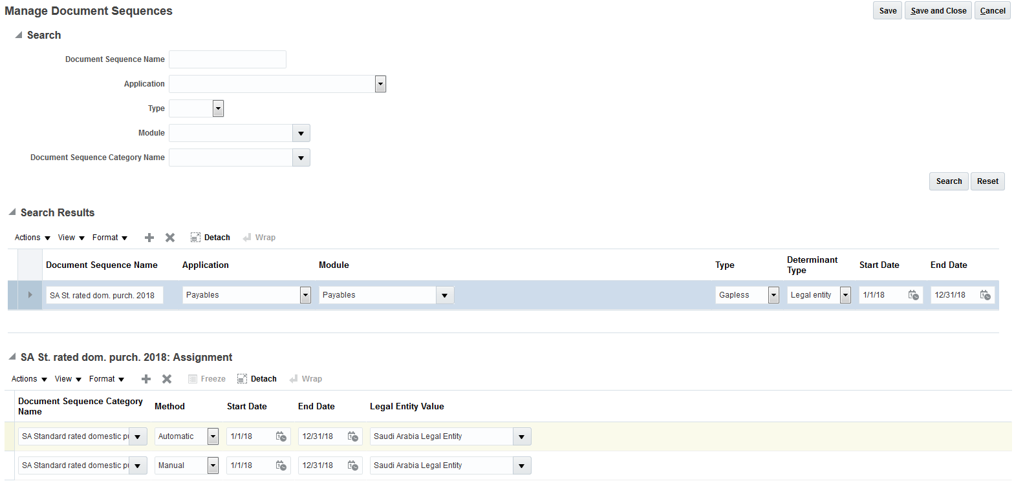

Screenshot 2 - ‘SA St. rated dom. purch. 2018’ document sequence and Payables Document Categories ‘SA Standard rated domestic purchases’ assignment creation
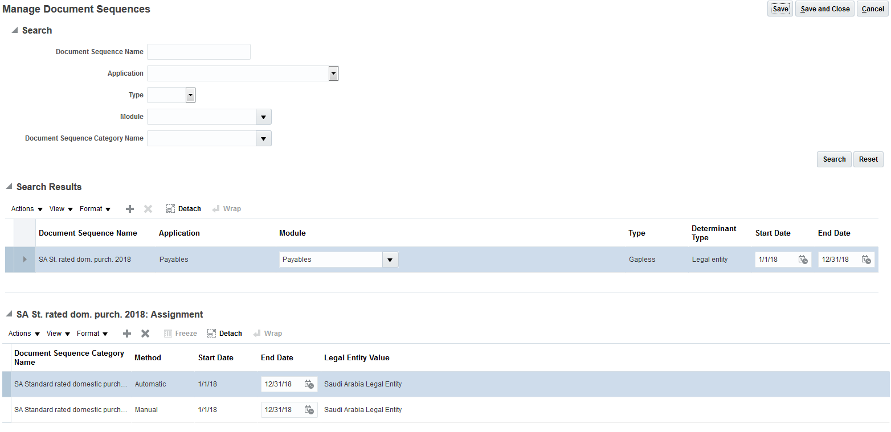
Create the Payables and Receivables Document Sequences, and assign them to the related Payables Document Categories and Receivables Transaction Types as previously defined; below table is an example.
Document Sequence
 | Document Sequence: Assignment
Document Sequence Name | Application | Module | Type | Determinant Type | Start Date | End Date
SA St. rated dom. purch. 2018 | Payables | Payables | Gapless | Legal Entity | 01/01/2018 | 12/31/2018
 | Document Sequence Category Name |  |  | Method | Start Date | End Date
 | SA Standard rated domestic purchases |  |  | Automatic | 01/01/2018 | 12/31/2018
 | SA Standard rated domestic purchases |  |  | Manual | 01/01/2018 | 12/31/2018
Document Sequence Name | Application | Module | Type | Determinant Type | Start Date | End Date
SA Import VAT customs 2018 | Payables | Payables | Gapless | Legal Entity | 01/01/2018 | 12/31/2018
 | Document Sequence Category Name |  |  | Method | Start Date | End Date
 | SA Import subject to VAT paid at customs |  |  | Automatic | 01/01/2018 | 12/31/2018
 | SA Import subject to VAT paid at customs |  |  | Manual | 01/01/2018 | 12/31/2018
Document Sequence Name | Application | Module | Type | Determinant Type | Start Date | End Date
SA Import reverse charge 2018 | Payables | Payables | Gapless | Legal Entity | 01/01/2018 | 12/31/2018
 | Document Sequence Category Name |  |  | Method | Start Date | End Date
 | SA Import subject to reverse charge |  |  | Automatic | 01/01/2018 | 12/31/2018
 | SA Import subject to reverse charge |  |  | Manual | 01/01/2018 | 12/31/2018
Document Sequence Name | Application | Module | Type | Determinant Type | Start Date | End Date
SA Zero rated purchases 2018 | Payables | Payables | Gapless | Legal Entity | 01/01/2018 | 12/31/2018
 | Document Sequence Category Name |  |  | Method | Start Date | End Date
 | SA Zero rated purchases |  |  | Automatic | 01/01/2018 | 12/31/2018
 | SA Zero rated purchases |  |  | Manual | 01/01/2018 | 12/31/2018
Document Sequence Name | Application | Module | Type | Determinant Type | Start Date | End Date
SA Exempt purchases 2018 | Payables | Payables | Gapless | Legal Entity | 01/01/2018 | 12/31/2018
 | Document Sequence Category Name |  |  | Method | Start Date | End Date
 | SA Exempt purchases |  |  | Automatic | 01/01/2018 | 12/31/2018
 | SA Exempt purchases |  |  | Manual | 01/01/2018 | 12/31/2018
Document Sequence Name | Application | Module | Type | Determinant Type | Start Date | End Date
SA St. rated dom. sales 2018 | Receivables | Receivables | Gapless | Legal Entity | 01/01/2018 | 12/31/2018
 | Document Sequence Category Name |  |  | Method | Start Date | End Date
 | SA Invoice Standard rated domestic sales |  |  | Automatic | 01/01/2018 | 12/31/2018
 | SA Invoice Standard rated domestic sales |  |  | Manual | 01/01/2018 | 12/31/2018
 | SA CM Standard rated domestic sales |  |  | Automatic | 01/01/2018 | 12/31/2018
 | SA CM Standard rated domestic sales |  |  | Manual | 01/01/2018 | 12/31/2018
Document Sequence Name | Application | Module | Type | Determinant Type | Start Date | End Date
SA Sales other GCC states 2018 | Receivables | Receivables | Gapless | Legal Entity | 01/01/2018 | 12/31/2018
 | Document Sequence Category Name |  |  | Method | Start Date | End Date
 | SA Invoice Sales to registered customers in other GCC states |  |  | Automatic | 01/01/2018 | 12/31/2018
 | SA Invoice Sales to registered customers in other GCC states |  |  | Manual | 01/01/2018 | 12/31/2018
 | SA CM Sales to registered customers in other GCC states |  |  | Automatic | 01/01/2018 | 12/31/2018
 | SA CM Sales to registered customers in other GCC states |  |  | Manual | 01/01/2018 | 12/31/2018
Document Sequence Name | Application | Module | Type | Determinant Type | Start Date | End Date
SA Zero rated dom. sales 2018 | Receivables | Receivables | Gapless | Legal Entity | 01/01/2018 | 12/31/2018
 | Document Sequence Category Name |  |  | Method | Start Date | End Date
 | SA Invoice Zero rated domestic sales |  |  | Automatic | 01/01/2018 | 12/31/2018
 | SA Invoice Zero rated domestic sales |  |  | Manual | 01/01/2018 | 12/31/2018
 | SA CM Zero rated domestic sales |  |  | Automatic | 01/01/2018 | 12/31/2018
 | SA CM Zero rated domestic sales |  |  | Manual | 01/01/2018 | 12/31/2018
Document Sequence Name | Application | Module | Type | Determinant Type | Start Date | End Date
SA Zero rated exports 2018 | Receivables | Receivables | Gapless | Legal Entity | 01/01/2018 | 12/31/2018
 | Document Sequence Category Name |  |  | Method | Start Date | End Date
 | SA Invoice Zero rated exports |  |  | Automatic | 01/01/2018 | 12/31/2018
 | SA Invoice Zero rated exports |  |  | Manual | 01/01/2018 | 12/31/2018
 | SA CM Zero rated exports |  |  | Automatic | 01/01/2018 | 12/31/2018
 | SA CM Zero rated exports |  |  | Manual | 01/01/2018 | 12/31/2018
Document Sequence Name | Application | Module | Type | Determinant Type | Start Date | End Date
SA Exempt sales 2018 | Receivables | Receivables | Gapless | Legal Entity | 01/01/2018 | 12/31/2018
 | Document Sequence Category Name |  |  | Method | Start Date | End Date
 | SA Invoice Exempt sales |  |  | Automatic | 01/01/2018 | 12/31/2018
 | SA Invoice Exempt sales |  |  | Manual | 01/01/2018 | 12/31/2018
 | SA CM Exempt sales |  |  | Automatic | 01/01/2018 | 12/31/2018
 | SA CM Exempt sales |  |  | Manual | 01/01/2018 | 12/31/2018

VAT Reporting Setup

Tax Reporting Configuration tab
Task name: Manage Tax Registrations
Navigation: Navigator –> Setup and Maintenance -> Manage Tax Registrations -> Search for: Legal Reporting Unit Tax Profile -> Tax Reporting Configuration tab
The Tax Reporting Configuration determines a reporting configuration based on the Tax Registration Number (TRN) defined for Legal Reporting Unit Tax Registration. This is the basis for country-specific tax reporting. This configuration refers to the Tax Reporting Entity. An entity identifier uniquely identifies a Tax Reporting Entity, which is the combination of Legal Entity, Tax Registration Number and Tax Regime.
To create VAT Registers under Reporting Configuration tab, Common Configuration subtab:
- Select the Tax Calendar
- Enable ‘Tax Register’ check box; this enables the Tax Registers subtab.
(Note: To create VAT Calendar and Tax Registers see pages 25 to27 below)
Screenshot 1 – Tax Reporting Configuration tab and Common Configuration subtab definition
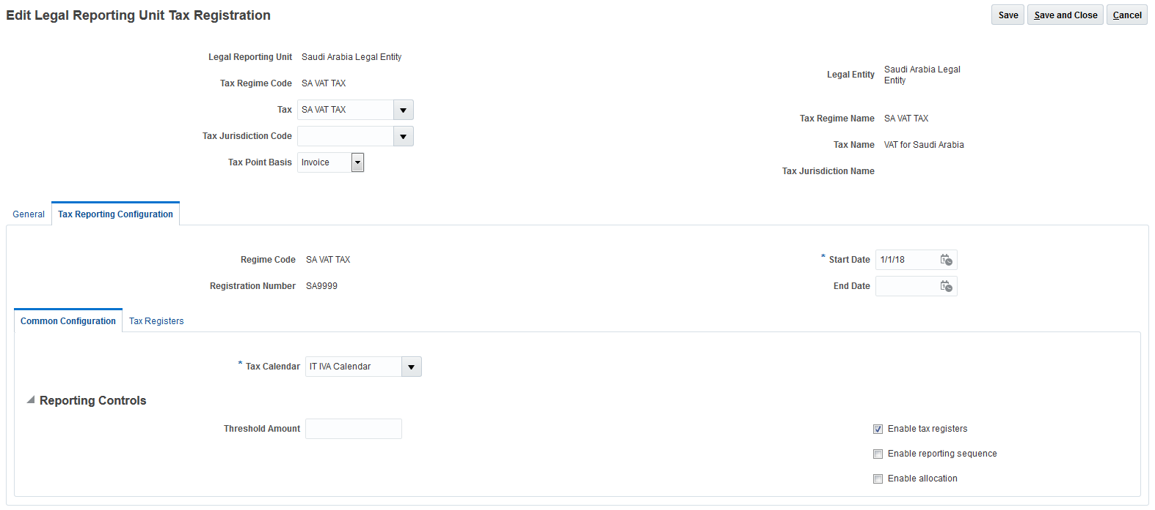

Screenshot 2 –Tax Reporting Configuration tab and Tax Registers subtab definition (example with Purchase VAT Register named ‘Purchases - SA St. rated dom. purch. 2018’)
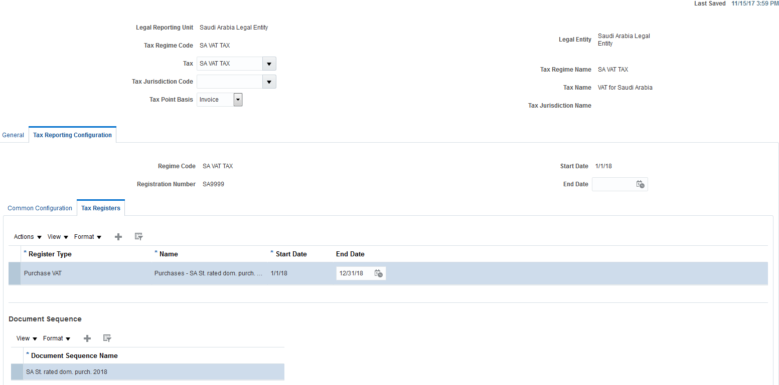

Table below is an example of a VAT Calendar.
Note
The VAT Calendar below is based on the assumption that VAT Registers are submitted on a monthly basis. The period frequency can be adapted as required.
Calendar
 | Period Details
Name | Description |  | Period Frequency | Adjustment Period Frequency | Budget Control Only | Start Date
VAT Calendar | VAT Calendar |  | Monthly | No | No | 1/1/2018
 | Period Name | Year |  | Period Number | Start Date | End Date
 | Jan-2018 | 2018 |  | 1 | 01/01/2018 | 01/31/2018
 | Feb-2018 | 2018 |  | 2 | 02/01/2018 | 02/28/2018
 | Mar-2018 | 2018 |  | 3 | 03/01/2018 | 03/31/2018
 | Apr-2018 | 2018 |  | 4 | 04/01/2018 | 04/30/2018
 | May-2018 | 2018 |  | 5 | 05/01/2018 | 05/31/2018
 | Jun-2018 | 2018 |  | 6 | 06/01/2018 | 06/30/2018
 | Jul-2018 | 2018 |  | 7 | 07/01/2018 | 07/31/2018
 | Aug-2018 | 2018 |  | 8 | 08/01/2018 | 08/31/2018
 | Sep-2018 | 2018 |  | 9 | 09/01/2018 | 09/30/2018
 | Oct-2018 | 2018 |  | 10 | 10/01/2018 | 10/31/2018
 | Nov-2018 | 2018 |  | 11 | 11/01/2018 | 11/30/2018
 | Dec-2018 | 2018 |  | 12 | 12/01/2018 | 12/31/2018
 | Jan-2019 | 2019 |  | 1 | 01/01/2019 | 01/31/2019
 | … | … |  | … | … | …
 | Dec-2019 | 2019 |  | 12 | 12/01/2019 | 12/31/2019
 | Jan-2020 | 2020 |  | 1 | 01/01/2020 | 01/31/2020
 | … | … |  | … | … | …
 | Dec-2020 | 2020 |  | 12 | 12/01/2020 | 12/31/2020

Create the VAT Registers and assign them to the related Payables and Receivables Document Sequences previously defined as shown below in the example.
Note
The VAT Registers below are based on the assumption that VAT Registers must be printed on a monthly basis (as per VAT Calendar) but must display all invoices related to a Calendar Year (see Start Date and End Date values). Therefore, at the end of month all VAT Registers are submitted.
Register Type
 | Document Sequence
Register Type |  | Register Name | Start Date | End Date
Purchase VAT |  | Purchases - SA St. rated dom. purch. 2018 | 01/01/2018 | 12/31/2018
 | Document Sequence
 | SA St. rated dom. purch. 2018
Register Type |  | Register Name | Start Date | End Date
Purchase VAT |  | Purchases - SA Import VAT customs 2018 | 01/01/2018 | 12/31/2018
 | Document Sequence
 | SA Import VAT customs 2018
Register Type |  | Register Name | Start Date | End Date
Purchase VAT |  | Purchases - SA Import reverse charge 2018 | 01/01/2018 | 12/31/2018
 | Document Sequence
 | SA Import reverse charge 2018
Register Type |  | Register Name | Start Date | End Date
Purchase VAT |  | Purchases - SA Zero rated purchases 2018 | 01/01/2018 | 12/31/2018
 | Document Sequence
 | SA Zero rated purchases 2018
Register Type |  | Register Name | Start Date | End Date
Purchase VAT |  | Purchases - SA Exempt purchases 2018 | 01/01/2018 | 12/31/2018
 | Document Sequence
 | SA Exempt purchases 2018
Register Type |  | Register Name | Start Date | End Date
Sales VAT |  | Sales – SA Stand. dom. sales 2018 | 01/01/2018 | 12/31/2018
 | Document Sequence
 | SA Stand. dom. sales 2018
Register Type |  | Register Name | Start Date | End Date
Sales VAT |  | Sales – SA Sales other GCC states 2018 | 01/01/2018 | 12/31/2018
 | Document Sequence
 | SA Sales other GCC states 2018
Register Type |  | Register Name | Start Date | End Date
Sales VAT |  | Sales - SA Zero rated dom. sales 2018 | 01/01/2018 | 12/31/2018
 | Document Sequence
 | SA Zero rated dom. sales 2018
Register Type |  | Register Name | Start Date | End Date
Sales VAT |  | Sales - SA Zero rated exports 2018 | 01/01/2018 | 12/31/2018
 | Document Sequence
 | SA Zero rated exports 2018
Register Type |  | Register Name | Start Date | End Date
Sales VAT |  | Sales - SA Exempt sales 2018 | 01/01/2018 | 12/31/2018
 | Document Sequence
 | SA Exempt sales 2018

VAT Reporting Submission

Transactions Extraction
Scheduled Processes: Select Transactions for Tax Reporting
Navigation: Navigator –> Tools -> Selected Processes -> Select Transactions for Tax Reporting
At the end of the VAT Calendar period, submit the ‘Select Transactions for Tax Reporting’ in order to extract all Payables and Receivables transactions for VAT Reporting.
Note
The ‘Select Transactions for Tax Reporting’ extracts the accounted Payables and Receivables transactions.
Submit the ‘Select Transactions for Tax Reporting’:
- Reporting Level = Legal entity
- Ledger = null
- Tax Registration Number = Tax Registration Number of the Legal Entity as per Tax Reporting Configuration tab definition
- Tax Calendar Period = The VAT Calendar Period as per Tax Reporting Configuration tab definition
- Source = Output tax and input tax
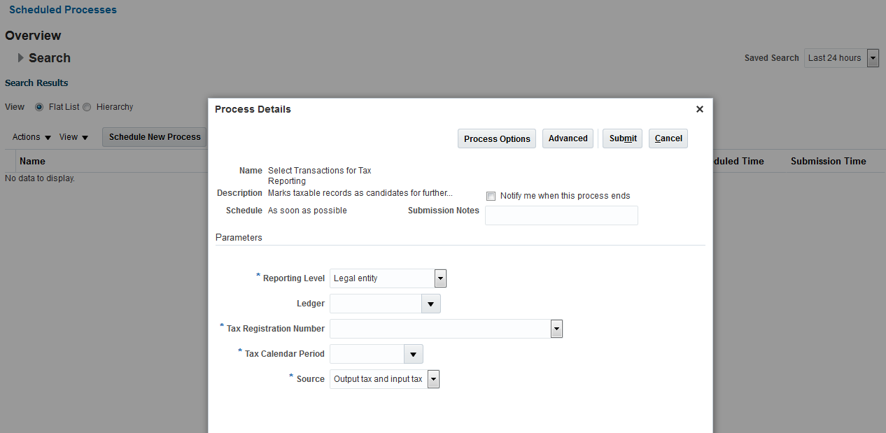

Sales VAT Register
Scheduled Processes: Receivables Sales VAT Register for Italy
Navigation: Navigator –> Tools -> Selected Processes -> Receivables Sales VAT Register for Italy
At the end of VAT Calendar period, after submitting the ‘Select Transactions for Tax Reporting’, submit the ‘Receivables Sales VAT Register for Italy’.
Submit the ‘Receivables Sales VAT Register for Italy’:
- Reporting ldentifier = Reporting Identifier as defined in Tax Reporting Configuration
- Tax Calendar Period = The VAT Calendar Period as per ‘Select Transactions for Tax Reporting’ previously submitted
- Tax Register = The Sales VAT Register Name as per Tax Reporting Configuration tab (see below Note)
- First Page Number = 1
Note
Follow the same process to submit all defined Sales VAT Registers:
- Sales – SA Stand. dom. sales 2018
- Sales – SA Sales other GCC states 2018
- Sales – SA Zero rated dom. sales 2018
- Sales – SA Zero rated exports 2018
- Sales – SA Exempt sales 2018
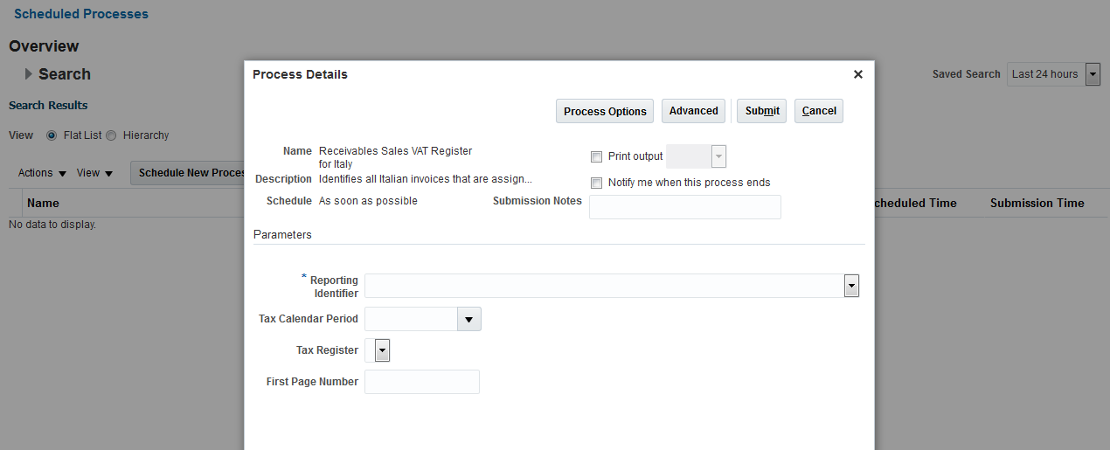

Purchase VAT Register
Scheduled Processes: Purchase VAT Register for Italy
Navigation: Navigator –> Tools -> Selected Processes -> Purchase VAT Register for Italy
At the end of VAT Calendar period, after submitting the ‘Select Transactions for Tax Reporting’, submit the ‘Purchase VAT Register for Italy’.
Submit the ‘Purchase VAT Register for Italy’:
- Reporting ldentifier = Reporting Identifier as defined in Tax Reporting Configuration
- Tax Calendar Period = The VAT Calendar Period as per ‘Select Transactions for Tax Reporting’ previously submitted
- Tax Register = The Purchases VAT Register Name as per Tax Reporting Configuration tab (see below Note)
- First Page Number = 1
Note
Follow the same process for all defined Purchase VAT Registers:
- Purchases – SA St. rated purch. 2018
- Purchases – SA Import VAT customs 2018
- Purchases – SA Import reverse charge 2018
- Purchases – SA Zero rated purchases 2018
- Purchases – SA Exempt purchases 2018
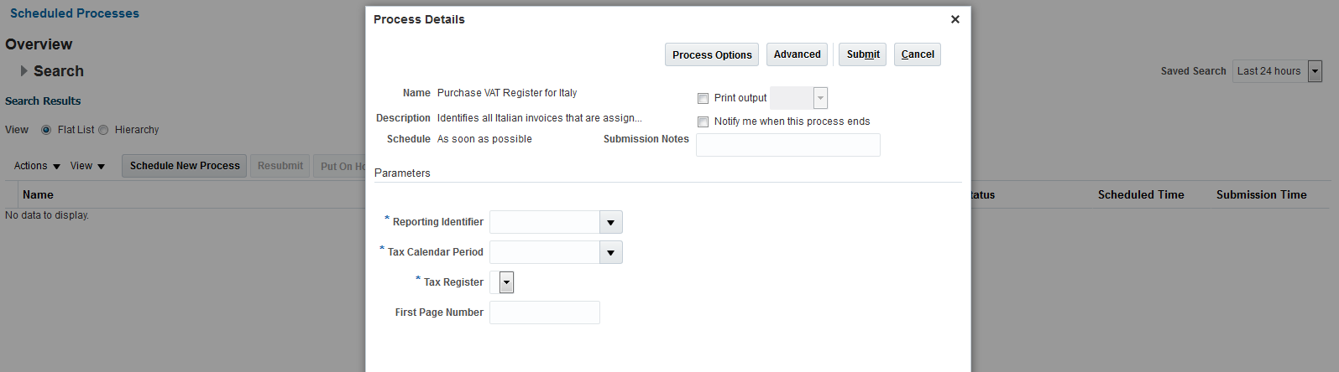

Examples of VAT Register Layout
Scheduled Processes: Receivables Sales VAT Register for Italy
Navigation: Navigator –> Tools -> Selected Processes -> Receivables Sales VAT Register for Italy

Example of Receivables Sales VAT Register for Italy
The layout is in PDF and composed of three sections:
- Header, which prints the Legal Entity identification (Name, Address, VAT Registration Number, Fiscal Code, Report Submission Date, Page Number);
- Body, which prints the Sequence Reporting Number, Invoice identification (Subledger Sequence Name, Subledger Sequence Number, GL Accounting, Invoice Number, Invoice Date, Third Party Name, Third Party VAT Registration Number), Invoice Tax information grouped by Tax Code (Tax Code, Taxable Amount, Tax Amount);
- Summary, which prints the Tax information grouped by Tax Code (Tax Rate, Tax Code, Taxable Amount and Tax Amount).
Note
According to the Tax Point Basis (Invoice, Payment) the Invoice Tax information (Body section) and the Tax information grouped by Tax Code (Summary section), the taxable and tax amounts are printed under the following:
- Invoice: Taxable Amount and Tax Amount columns;
- Payment: Deferred Taxable Amount and Deferred Tax Amount columns.
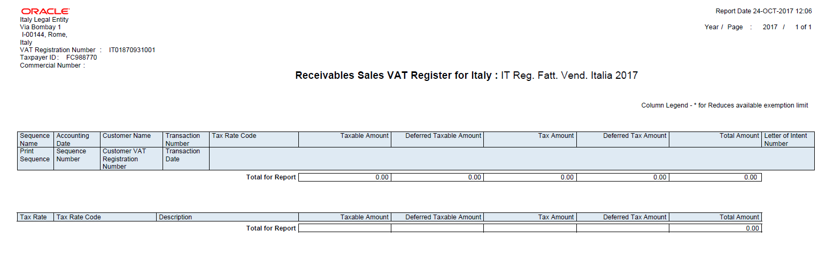

Example of Purchase VAT Register for Italy
The layout is in PDF and composed of three sections:
- Header, which prints the Legal Entity identification (Name, Address, VAT Registration Number, Fiscal Code, Report Submission Date, Page Number);
- Body, which prints the Sequence Reporting Number, Invoice identification (Subledger Sequence Name, Subledger Sequence Number, GL Accounting, Invoice Number, Invoice Date, Third Party Name, Third Party VAT Registration Number), Invoice Tax information grouped by Tax Code (Tax Code, Taxable Amount, Tax Amount);
- Summary, which prints the Tax information grouped by Tax Code (Tax Rate, Tax Code, Taxable Amount and Tax Amount).
Note
According to the Tax Point Basis (Invoice, Payment) the Invoice Tax information (Body section) and the Tax information grouped by Tax Code (Summary section), the taxable and tax amounts are printed under the following:
- Invoice: Taxable Amount and Tax Amount columns;
- Payment: Deferred Taxable Amount and Deferred Tax Amount columns.
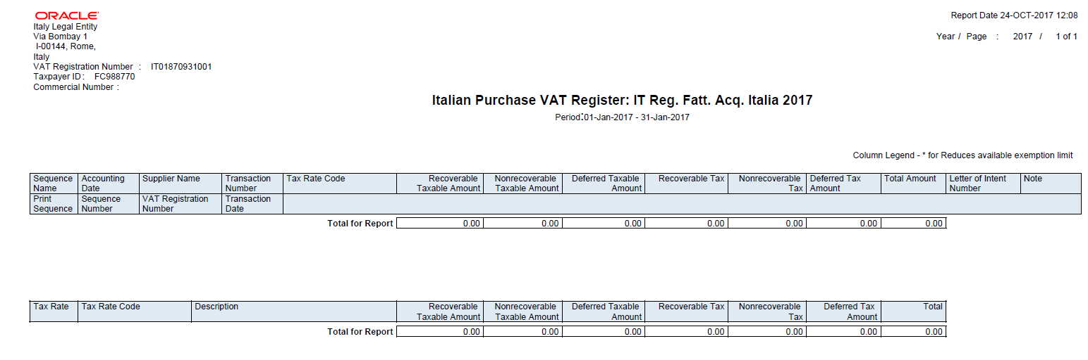

 | Oracle Corporation, World Headquarters Worldwide Inquiries  500 Oracle Parkway Phone: +1.650.506.7000  Redwood Shores, CA 94065, USA Fax: +1.650.506.7200
Connect with us   blogs.oracle.com/oracle   facebook.com/oracle   twitter.com/oracle   oracle.com  Connect with us   blogs.oracle.com/oracle   facebook.com/oracle   twitter.com/oracle   oracle.com  Connect with us  blogs.oracle.com/oracle  facebook.com/oracle  twitter.com/oracle  oracle.com | Copyright © 2017, Oracle and/or its affiliates. All rights reserved. This document is provided for information purposes only, and the contents hereof are subject to change without notice. This document is not warranted to be error-free, nor subject to any other warranties or conditions, whether expressed orally or implied in law, including implied warranties and conditions of merchantability or fitness for a particular purpose. We specifically disclaim any liability with respect to this document, and no contractual obligations are formed either directly or indirectly by this document. This document may not be reproduced or transmitted in any form or by any means, electronic or mechanical, for any purpose, without our prior written permission.  Oracle and Java are registered trademarks of Oracle and/or its affiliates. Other names may be trademarks of their respective owners.  Intel and Intel Xeon are trademarks or registered trademarks of Intel Corporation. All SPARC trademarks are used under license and are trademarks or registered trademarks of SPARC International, Inc. AMD, Opteron, the AMD logo, and the AMD Opteron logo are trademarks or registered trademarks of Advanced Micro Devices. UNIX is a registered trademark of The Open Group. 1117  White Paper Title  November 2017


